

CANADIAN MENTAL HEALTH ASSOCIATION PRINCE GEORGE BRANCH

ANNUAL REPORT
2013 - 2014

Mentally Healthy People in a Healthy Society
Mission Statement
The Canadian Mental Health Association (CMHA) Prince George Branch exists to promote the mental health of individuals living within the Prince George and surrounding area, and support the resiliency and recovery of people experiencing mental illness.
TABLE OF CONTENTS
Introduction
Executive Director’s Report
Program Manager Report

Programs
Bounce Back: Reclaim Your Health
Life Skills Outreach
Forensics Life Skill Program
Peer Support
Connections Clubhouse
Vocational Support Services
Housing Outreach
CMHA New Directions Housing
Disability Project
Mental Health and Police Project
Mental Health First Aid
Heartbeat
Living Life to the Full
Seniors Outreach
Two Rivers Catering
Second Chance Thrift Store

Events
Gift of Hope
Women & Wellness
Mental Health Week
Depression Screening/ Beyond the Blues
Ride don’t Hide

People of CMHA
Board Members
Staff
Volunteers
Funders/Supporters
Words from those we serve

EXECUTIVE DIRECTOR’S REPORT
Another year of change and growth is under our belts! We worked hard at laying the foundation for a physical move as well as rising to the challenge of doing even more work to support individuals in a continually restricting financial environment.
So many thanks are due to so many people who have helped support our aims - those individuals were internal to our organization as well as some very committed community members. I especially want to thank CMHA staff and volunteers – particularly board members who have been called upon to give more and more at a complicated and challenging level. I wish I could say that we are settling into a time period of stability but change is constantly on the horizon and I am grateful for all those around CMHA aims and goals who understand and embrace the certainty of change. Huge thanks to new people in our lives – Ken Goss, George Weinand, Vern and Justin Norbraten, Garrett Murphy and all the business and individuals who gave so much in the preparation of our new building. With this physical change we will be better prepared for our future.
Maureen Davis MEd

PROGRAM MANAGER REPORT
Once again it has been a busy year with changes and growth of our agency. We welcomed several new staff Jeannine, D’Arcy, Gwen and Tatyana.
We continue working on getting the new database going and we are almost there. I am happy to report that all clients are entered and we are fine tuning some items and getting the reports all set.
We were invited to attend the Ministry of Justice Blue Ribbon Panel on Crime reduction and we were able to speak to the needs of increased education for first responders. We have also been invited to Lakeland Mills discussions regarding support for their employees returning to work.
We have continued to grow in our education offerings and presented MHFA in Quesnel a new town for us this year, also we present our mental Health Crisis Response Training in Ft. St. John it was exciting to see how this training can be rolled out in other communities.
Mary Lu Spagrud, BRS
Program Manager

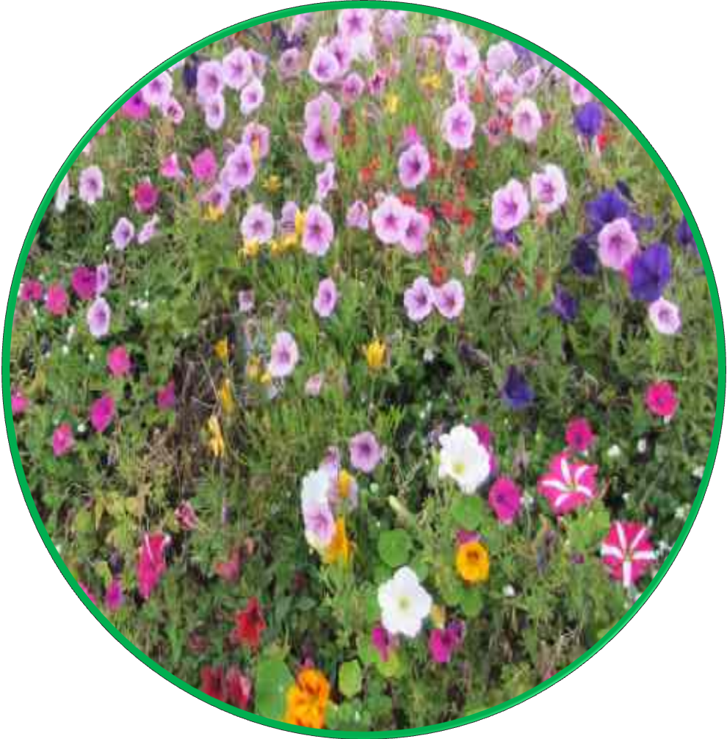

PROGRAMS

BOUNCE BACK: RECLAIM YOUR HEALTH
Funded by CMHA BC Division
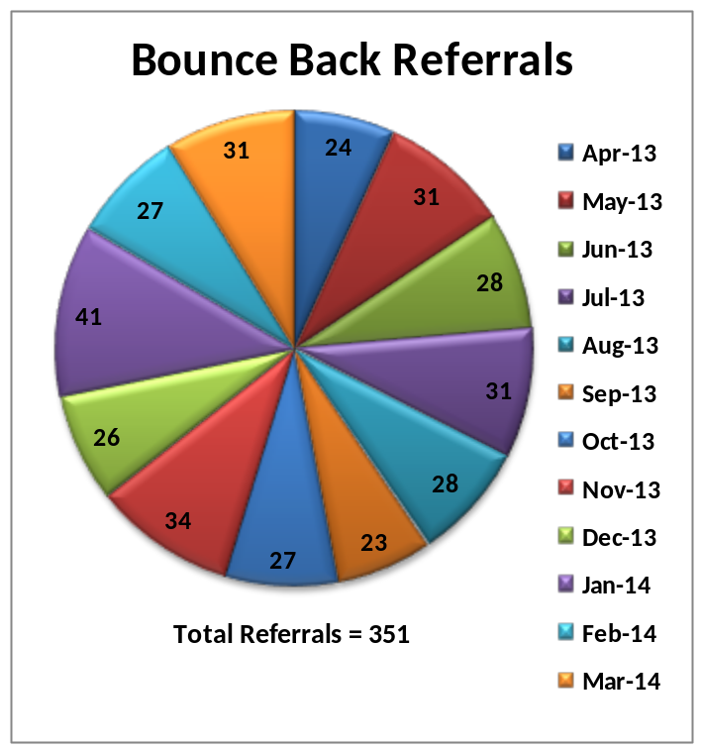Bounce Back: Reclaim Your Health is a program employing 1 full-time staff member as a Community Coach and 1 part-time staff member as Bounce Back Administrative Support. Bounce Back is a free, skill-building program to help adults (19 years and older) experiencing signs of depression and/or anxiety. Through a DVD, workbooks and telephone coaching with a Community Coach, participants learn effective strategies for overcoming difficulties such as inactivity, avoidance, worry and unhelpful thinking. The program is promoted throughout the Northern Health Region by face to face and phone/mail contacts with medical practitioners/community partners who provide the referrals. In addition to the statistics shown, Bounce Back distributed over 2,485 DVDs in the north this year and completed two successful BB Road trips; one to Northwestern BC and the other to Northeastern BC. As well, the Bounce Back Community Coach attended numerous presentations and health fairs throughout the year promoting Bounce Back as well as CMHA services. The Bounce Back program received an award for excellence in health promotion. The award received was the Northern British Columbia “A Healthier You – Mental Health in the Workplace” award.

LIFE SKILLS OUTREACH
Funded by Northern Health
The Life Skills Program is in its 29th year and continues to be CMHA’S largest community service. Life Skills Outreach provides services to individuals living with mental illness and/or substance abuse issues. The service is designed to promote and assist individuals to gain or regain skills to maintain their independence in the community. In the past year, our team of 4 full time and 1 part time staff provided service to 64 clients on a regularly scheduled basis. Some of the life skills clients receive service 2 or 3 times weekly, others weekly or biweekly. Our services run 7 days a week 365 days of the year. At the end of March this year we had a waiting list of 5 people waiting for service the longest of these had been referred in December. We are currently working with Northern Health to review all clients and their current needs for lifeskills. We predict an increase in the waitlist as client needs increase as we are serving more geriatric based clients who need increasing service and assistance.
The services provided to our clients were as varied as the individuals themselves: daily life skills such as personal hygiene, laundry, home maintenance, grocery shopping, banking and budgeting; and building personal skills in areas such as accessing the community and learning to manage their anxiety. Also provided was support with appointments and medical and medication issues. CMHA remains committed to ensuring our service meets the need of clients and we are focused on quality of service and not just quantity of numbers served.
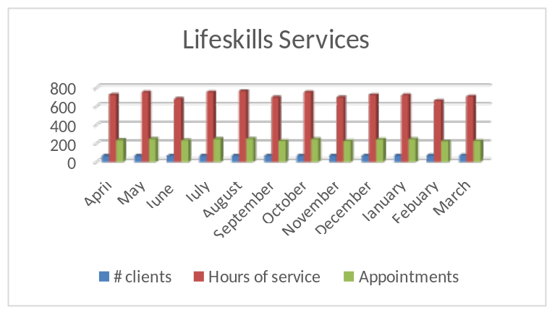Other very important work of life skills is ensuring our clients are connected to community services and receive the medical attention they require. We respond to our clients when they are in crisis and provide phone support and attend case conferences to ensure their words and needs are supported. We continue to experience the impact of a lack of funding increases and reduced community programming which results in clients with higher needs and fewer community options.

FORENSICS LIFE SKILL PROGRAM
Funded by Forensics
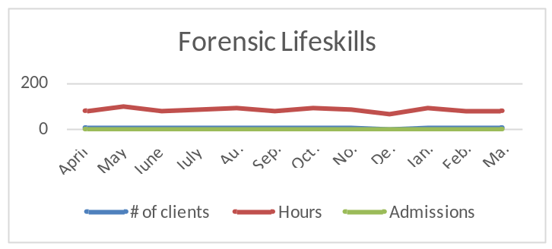The Forensics Lifeskills Program works with individuals referred by Forensic Psychiatric Services Commission (FPSC). This part-time program provides lifeskills to individuals living with a mental illness and/or addiction, who have been in conflict with the law.
This program assists individuals in a variety of ways. Support can include budgeting, personal hygiene, grocery shopping, bill payments, medication pickup, medical appointments, banking as well as finding and securing housing.

PEER SUPPORT (section needs to be done with charts.)
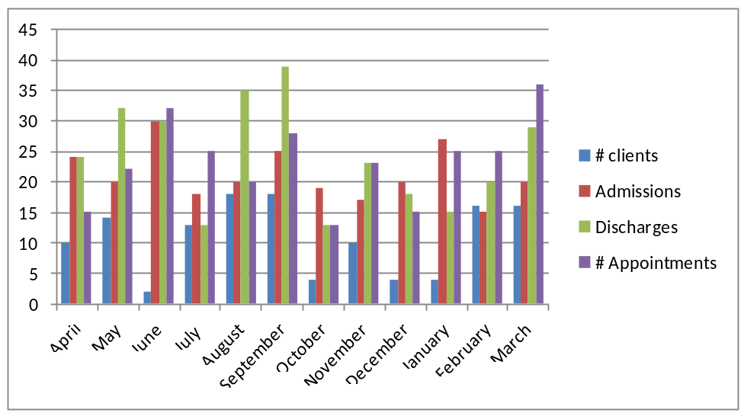Funded by Northern Health
The part time Peer Support Program (.6FTE) provides a variety of activities to help Mental Health consumers, both in office and outreach in the community. Our employee works diligently assisting people with issues involving financial, legal, employment, mental and physical health, accompaniment, access to services, participating in community meetings, finding information and resources and keeping up to date on issues and information affecting the Mental Health Community. The Peer Support Program is a member of the PG Mental Health Consumer Council providing a mentorship role and networking with community partners. This program also coordinates the Positively Peer Program which provides companionship and information to patients on the psychiatric unit at the hospital. Last year we connected with 409 patients.
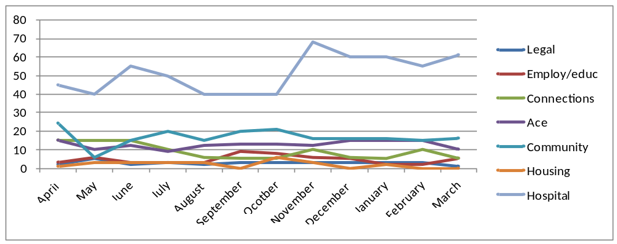The Peer Support chart above shows how deeply committed we are to ensuring our clients are connected to services and supports which ensure improvements in their mental health. This program needs to be full time in order to best meet the growing demands of individuals who seek assistance.
CONNECTIONS CLUBHOUSE
Funded by Northern Health, Sales and Fundraising

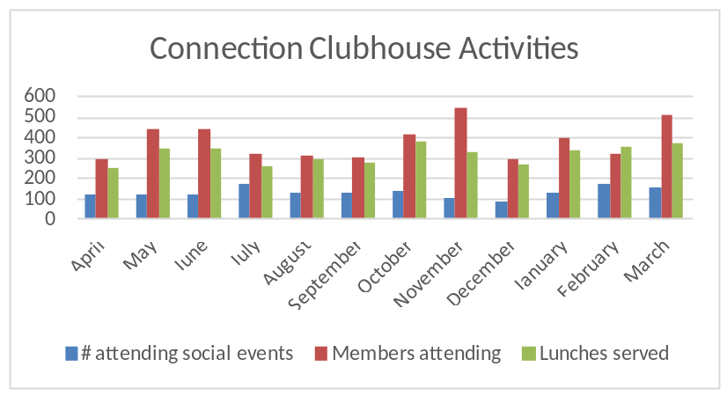 Connections Clubhouse is a social/recreational program of CMHA and membership is open to anyone with mental health/addictions issues and provides a variety of social and recreational activities to its members as well as lunches served five times per week by Two Rivers Catering. Over the past year we have provided many activities, some in partnership with Northern Health and ACE. On special occasions such as Thanksgiving and Christmas a full course turkey dinner is provided as well as special events such as dances, bocce tournaments and the increasingly popular Western Carnival.

VOCATIONAL SUPPORT SERVICES
Funded by Northern Health

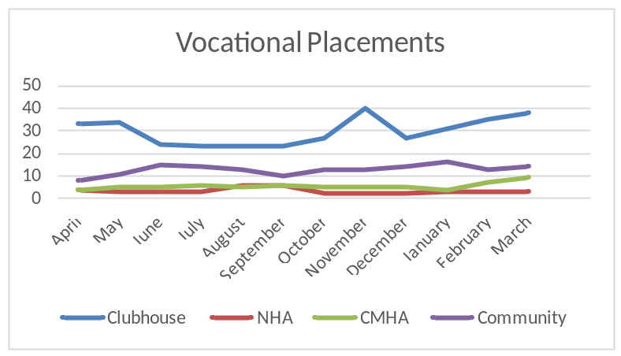The Vocational Support Program works in conjunction with Rehab Services of the Northern Health Authority. The program goal is to assist individuals with mental illness and/or substance use issues in developing vocational skills which will lead to improvements in job readiness as they work towards paid or volunteer employment or education in their area of interest. Challenges for the program include needing more community based supported employment/volunteer sites and the time to find and arrange these placements. It is felt that more time is required to provide more individualized support to clients to help them become successful in their goals

Support Levels provided

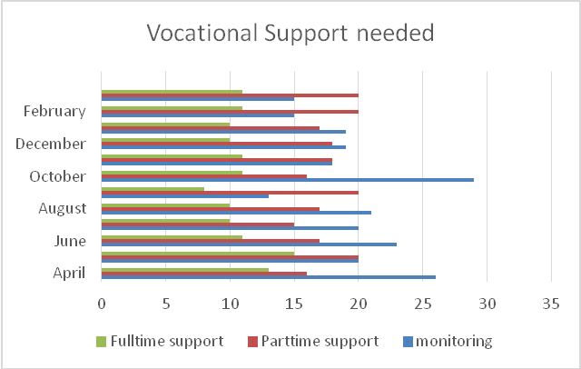

HOUSING OUTREACH
Funded by City of Prince George and Northern Health
Resource Housing Outreach is a part time position designed to assist people experiencing mental health concerns access affordable and safe housing in the community. There have been many changes during the fiscal year which has had a marked impact on the Resource Housing Outreach program. Funding changes saw a reduction in hours to 13 hours/week, change in the program staff during October 2013, and a change in the housing market has further impacted the reach of the position.
A reduction in hours also brought with it fewer numbers of drop-in clients with a counted 61 intakes over the fiscal year. Not all 61 intakes required housing as some were requesting assistance with applications to BC Housing and SAFER. Many of the clients were referred to CMHA Resource Housing Outreach by Northern Health, other agencies, and internally from other CMHA programs.
A change in staff in October also saw some changes in the Resource Housing Outreach Program. Recognizing the scarcity of affordable safe housing as well as limited availability of services hours, alternative solutions and community partnerships were sought.
Where previously it was the job of the outreach worker to track vacancies in the community, a partnership with Ketso Yoh housing outreach has made a community wide housing list available on a weekly basis thereby freeing more time for the outreach worker to focus on client needs. This record of vacancies has demonstrated a rapid increase of rental rates and a decline in availability. The most recent UNBC homeless count reviled Prince George as having a vacancy rate of between 1 and 2%; this reality is mirrored by the Ketso Yoh weekly housing list.
A community group was formed to further facilitate partnerships and housing supports. The group runs under the name “Building and Accessing Community Organization Networks”, or “B.A.C.O.N. Bits”. A breakfast meeting once a month is designed to encourage and foster interagency cooperation in supporting people seeking and maintaining housing. The group’s first meeting was in January 2014 and will be maintained on a monthly basis.
Building relationships with landlords became an obvious need as competition for rental units increased. An application to the Mental Health Commission of Canada SPARK, Knowledge in Translation program was made proposing the development of a Landlord Support Group with a similar format to the B.A.C.O.N group. The application-proposal was successful. Attendance at a training seminar in June 2014 followed by a year of mentorship to ensure program success has been committed to; travel expenses are covered by the MHCC grant.
As the fiscal year came to a close and the federal Housing First initiative became an eminent expectation across the country, Resource Housing Outreach program has intentionally become more focused on the strengths of “Resources” to support housing. Housing issues faced by persons experiencing mental health concerns who are at risk of homelessness, currently homeless, or in any other way experiencing housing challenges face the same difficulty as any person, however with the added complication of mental health issues and stigma. By making the CMHA’s expertise in Mental Health housing challenges available to agencies, organization, landlords, and individuals, a community of care may be developed to support effective, safe, secure housing in the face of limited availability. This support of existing community services and housing is the direction which the Resource Housing Outreach program is focusing attention and efforts as we enter the new fiscal year.

CMHA HOUSING (double check to make sure it is accurate)
MOSS HOUSE – Funded by Northern Health and Residents
CMHA Prince George continues to operate a subsidized housing program for individuals with severe and persistent mental illness. Moss House is a 5 bedroom group home and is currently occupied by 5 gentlemen. These individuals pay rent based on the government amount under Persons with Disabilities and contribute a weekly amount to groceries. Life skill workers assist individuals in developing skills and obtaining the resources and supports that they want and need in their particular living situation. The residents are responsible for the upkeep of their home, such as, meal preparation and participating in activities to assist in keeping them healthy and active in our community. The individuals living at Moss are involved in their community either with work in the private sector or with placements at the Clubhouse.
NEW DIRECTIONS HOUSING – Funded by BC Housing and Residents
CMHA operates subsidized housing units for persons with severe & persistent mental illness. Nineteen units, located throughout Prince George in various apartment buildings, provide individuals with safe, affordable housing with subsidized rents with BC Housing.
Many of our tenants have been in our housing for several years. This year, we had a turnover in 3 units, accommodating 2 new individuals with housing needs.? A waiting list exists as the demand for subsidized housing for persons with mental illness far exceeds availability.
This program is supported by a part time position of Housing Administrator whose job it is to maintain close connections with tenant, identify and ensure correction of deficiencies and act as an intermediary in resolving housing issues such as repair & maintenance concerns, safety concerns, rent increases, financial concerns with housing and so on, without having the clients deal directly with landlords or subsidy providers. This arrangement is meant to assist our tenant by removing housing worries, leaving them free to work on other areas of their goals toward independence and recovery.
The Housing Administrator also sits on the Community Mental Health Housing Committee which meets monthly to determine the best placements for individuals who apply for supported housing. Any openings in our apartments are filled with suitable applicants from the waiting list established within this community committee. MENTAL HEALTH AND POLICE PROJECT
Participant Time Donation Only
This project is facilitated by Mary Lu and is designed to improve responses by police officers and other first responders to people with mental illness in crisis. Through the involvement of RCMP, people with mental illness, their family members and crisis services such as the BC Ambulance Service and related mental health services including NHA, and community agencies, work is occurring to identify strengths and areas for improvement in our interactions with people experiencing a mental health crisis. This is the seventh year of operation of this committee and of the original nine communities in BC we are the only one still active. One of the most positive outcomes of this project and training is the stories we hear of police involvement which are primarily positive in nature. We completed 3 one day training opportunities this year and successfully presented one week of CIT training.

MENTAL HEALTH FIRST AID
Funded by Sales and Promotions
CMHA has 2 staff - Mary Lu and Tammy - who are Certified Instructors in Mental Health First Aid (Basic and Adults Who Interact With Youth). We had two bookings to travel to Ft. St. James to present MHFA but due to low registration both were cancelled and we have been rescheduled for the upcoming year.

MHFA teaches participants how to help someone with a mental health problem or experiencing a mental health crisis by identifying danger signs and learning how to take steps to preserve life. It also teaches how to recognize early warning signs of mental illness and how to intervene to support in the recovery of mental health.

The biggest challenges we face with MHFA is the lack of dedicated monies and time to support the development of the program while we compete within an uncertain market.

HEARTBEAT
Volunteer Based Supports
The effects of suicidal behavior or completed suicide on friends and family members are often devastating. Survivors may experience a great range of conflicting emotions about the deceased, feeling everything from intense emotional pain and sadness about the loss, helplessness to prevent it, longing for the person they lost, and anger at the deceased for taking their own life, up to emotions such as relief, particularly if the suicide took place after years of physical or mental illness in their loved one.

Individuals left behind by the suicide of a loved one tend to experience complicated grief in reaction to that loss. As a means to respond and assist in the healing process we offer Heartbeat on an ongoing monthly basis.
This is a group for mutual support of family and friends who have lost someone through suicide. Its’ goal is to help survivors understand the impact of suicide, to offer comfort and acceptance and to support each other through the grief and other feelings they may be experiencing.
This support group is facilitated by a wonderful volunteer Sandra Galletti, and we welcomed her mom Patricia Russell as a co-facilitator this year. As well as coordinating the group they were actively involved in World Suicide Day and Mental Health Week.

LIVING LIFE TO THE FULL
Funded by Sales and Promotions
CMHA is committed to expanding our public education offerings and with having 4 Living Life To The Fullest instructors we hope to promote more opportunities.

LLTTF is 12 hours that can change your life! This enjoyable, interactive course is taught over 8 weeks and is designed as a group course for anyone aged 19 and over. It introduces the principles of Five Areas of CBT (Cognitive Behaviour Therapy) and will help a person to understand their feelings and what to do about them through worksheets, moderated discussions and booklets for reading and support between sessions.

It is our goal when we move into our new space we will start offering LLTTF within our building.

TWO RIVERS CATERING
Funded by Sales from Catering and the Daily Lunch Program, as well as by Vancouver Foundation until June 2014
Two Rivers Catering is a social enterprise of CMHA PG, which was conceived as a way of creating employment opportunities for people who are living & dealing with serious and persistent mental health issues.
This business operates out of Connections Clubhouse, where the employees prepare daily lunches for Clubhouse Members, as well as preparing all food for the catering clientele.
Two Rivers Catering was previous funded by the Vancouver Foundation, and the goals are continuing to be implemented by the employees & volunteers as an opportunity to gain employment skills, & enhance independence and confidence while in a supported work environment and then integrate these new skills and knowledge into a community based employment.
Two Rivers Catering has made great strides in fulfilling its vision to empower individuals living with a mental health issue. To date 36 individuals have gone through the culinary arts program, 11 individuals are now hired, 2 part-time & 9 on call casual. Many Two Rivers employees have reported improvement in many aspects of their lives, in part due to their experience with the company. The majority of training for Two Rivers Catering kitchen staff has been the preparation of meals for consumers, consisting of well over 3500 meals during the past fiscal year, April 2013 to March 2014.
With the services of Patrick Olivier (and funding by Enterprising Non-Profits) we achieved a business plan which has solidified our plans for the next 5 years, and has helped us become self-sufficient now that the Vancouver Foundation funding has ceased in June of this year.
He has supported our plan of having scaled exposure events which allow our staff to have opportunities to challenge anxieties and build coping skills within the job.
For example, those working solely within the clubhouse can begin to assist with delivery to catering events – when ready they can then assist with serving at catering events and when feeling very confident can assist at the weddings catered by Two Rivers which presents the most challenges for individuals
Clientele testimonial:
“I have been accessing Two Rivers Catering since October 2011 to provide catering for the Department of Psychiatry here in Prince George, the program has provided outstanding service and excellent food” – Jean Jarabek, Admin Assistant Department of Psychiatry

Client Testimonial:
“Two Rivers catering has given me the faith and confidence in myself, improved my ability to work with others, practice my work & education skills, while I confidently pursue my independence.” - DC

Client type | # OF JOBS | % OF JOBS | INVOICED ($) | INVOICED (%)
Northern Health | 44 | 28% | $ 16,270.89 | 26%
Internal | 46 | 29% | $ 15,830.51 | 25%
Private Functions | 59 | 37% | $ 19,221.27 | 30%
Events (Public & Private) | 9 | 6% | $ 12,090.76 | 19%
Totals | 158 | 100% | $ 63,413.43 | 100%

SECOND CHANCE THRIFT STORE
Funded by Gaming and Sales
Second Chance – CMHA’s Thrift Store, continues to operate throughout the year, providing low priced used clothing and small household goods to the community. Totally relying on the generosity of donations for our goods, we have been fortunate to have wonderful community support in contributions to keep our racks and shelves well stocked.
This year we completed the Opportunities Grant which allowed for the employment of 4 individuals with severe and persistent mental illness. These women worked 20 hours a week each. This allowed the thrift store to be opened for longer hours, and really boosted sales. The other significant plus was the ability to have 2 people on per shift which was an enormous support to the small core group of Vocational Support clients and volunteers.
All these individuals do a wonderful job in sorting through donations, doing masses of laundry, ironing, pricing, stocking, cash-handling, learning till and policy procedures, and above all keeping our customers happy. The results occurred within the 2013/14 fiscal year we can support that 3 out of the 4 Opportunities Grant personnel successfully achieved work in the community or returned to school.
At this time we can acknowledge that sales for the thrift store have tripled and we anticipate being able to support more ongoing vocational support positions as time progresses. As the only sheltered retail spot in Prince George we are vital to the vocational support picture.



EVENTS

GIFT OF HOPE
Various Donors and Sponsors
Christmas would not be the same at CMHA without our annual event – The Gift of Hope. For over 20 years, CMHA has provided gifts to individuals living with mental illness and their children. The 2013 Christmas event hosted a Christmas dinner & dance attended by 228 individuals.
In 2012, 355 gifts were distributed, all due to the generosity of the Prince George community both individuals and businesses. Volunteers contributed 405 hours to sorting gifts, picking up donations, shopping, and gift delivery as well as countless hours baking and cooking to provide a full course turkey dinner and desserts. Santa visited the children, distributed gifts, door prizes were drawn and clients, family, staff and clinicians danced the night away.
The Gift of Hope is facing challenges as our long time hall resources that the Legion is no longer available. The challenge is to find a hall large enough to support up to 250 people and will allow us to use our volunteers to cook the meal. We are unable to support an event that would be catered at the usual rates. This reality may result in changes to how the Gift of Hope operates but we will ensure that the Gift of hope continues in some form for years to come.

MENTAL HEALTH WEEK (needs to be looked over)

Mental Health Week is a designated week created nationally by Canadian Mental Health Association to talk, reflect, engage and celebrate mental health for all. Celebrated from May 6th to 12th in 2013, this year’s theme was “Mental Health for All” with an emphasis on children and youth.
The Prince George Branch of CMHA celebrated Mental Health Week by handing out a “mental health tips” card, stapled with a packet of tea, to every teacher and support staff in School District #57. The cards linked having a cup of tea to the concepts of mental wellness – taking a moment, comfort, warmth, relaxation and stress relief. They also provided tips on mental wellness and a list of CMHA resources.
As well an information booth occurred at Kelly Road Secondary and every classroom at Spruceland Traditional School allowed us to do a 30 minute presentation on mental wellness. Members of the Opportunities Grant attended to share their stories of illness to health at age appropriate levels. Our thanks to Linda Picton (principal Spruceland Elementary) and Belinda Hanlon (Counsellor at Kelly Road) for their support in setting up these opportunities.
During this week, we also participated in the local May Day parade to promote Mental Health. A “Mental Wellness:” float was constructed by volunteers and consumers, and CMHA handed out 1,000 fortune cookies over the length of the parade. The cookies had a mental health encouragement on one side and “Canadian Mental Health Prince George” written on the reverse. As always, these cookies were extremely popular.

DEPRESSION SCREENING/ BEYOND THE BLUES
The 18th annual Depression Anxiety Education and Screening Day in BC took place on October 4th and 6th. We offered screening at two locations: CNC and ACE. Our goal was for people to learn the signs of depression, anxiety disorders and risky drinking and help connect to community supports. This event was free, anonymous, and confidential. CNC was very well attended by students and some high needs concerns were identified. While the ACE event was well attended only 1 participant chose to undergo the screening.
This was an education event and participants did not receive a diagnosis, but learned if they’d benefit from a more complete evaluation.
The program included the following:
- A brief depression self-test, anxiety self-test and risky drinking self-test for participants to complete; we asked that everyone complete all three tools.
- a 10-20 minute, one-on-one interview with a clinician to discuss the results of self-tests and next steps. This also included learning about community resources and receiving a follow-up sheet summarizing the results.
- Resource materials on depression, anxiety and related topics.
- A short exit survey for participants to fill out to help us plan and review.



PEOPLE OF CMHA
CMHA BOARD OF DIRECTORS(needs to be updated)
Greg Beattie President
Hilary McGregor Vice-President
Marian Muir Treasurer
Natalja Tchajkova Secretary
Phillip Clough
Callista Vagt
Hilary McGregor
Charles Scott
Francis Garwe

STAFF 2013-2014

Marie Bradley Casual Life Skills
Laurie Bryant Life Skills
Maureen Davis Executive Director
Lois Doran Life Skills
Gwen Neufeld Accounting
Mary Ellen Johnson Casual Life Skills
Michael Jordon Casual Life Skills
Tammy Lawson Bounce Back
Ed Lui Peer Support
Stacey MacAhonic Life Skills
Cheryl McKay Casual Life Skills
Clara Orr Vocational Support/Casual Life Skills
Joan Sherry Vocational Support
Jacqueline Sketchley Vocational Support
Terese Skoczylas Administrative/Volunteer Coordinator/Housing Administrator
Mary Lu Spagrud Program Manager
Joy St. Croix Life Skills
Lory Weibe Casual Life Skills
Marie Wilmot Casual Life Skills
D’Arcy Michiel Casual Life Skills
Jeannine Glowacki Casual Life Skills
Heidi Wilson Resource Housing /Alternate Paths
Tatyana Arrowsmith Resource Housing
Cheryl Young Vocational Support
Allen Zgaga Chef Two Rivers Catering
Debra Zsombor Accounting Administrator
Stacy Zsombor Forensic Life Skills/Life Skills
Janis Smith Heartbeat

VOLUNTEERS
Volunteers are an integral part of the operations of CMHA Prince George. They serve on the Board of Directors and help out with our many events and programs. Some hope to provide their services anonymously while others do not mind being acknowledged. In keeping with these differences, we want to acknowledge (without naming) the over 75 people who gave of their time and their hearts to making the world a better place for the people in Prince George who struggle with mental illness and in particular, struggle with the stigma still attached to being mentally ill. The over 8,000 hours of service from volunteers is priceless and will continue to help us work towards our aims of a world where mental illness and mental wellness receive the same level of support, understanding, and care as is typically provided to those struggling to regain physical wellness.

Thank You

FUNDERS AND COMMUNITY SUPPORTERS
Words From Those We Are Here For!

- 100% (22/22) felt the service was somewhat or very meaningful to them
- 100% (22/22) felt the goals were their own and built on their strengths.
- 86.3% (19/23) felt the process of reaching their goals were above average or higher
- 65% (15/23) were satisfied or very satisfied with the services they received.

“It is a very supportive and encouraging work environment.”

“Office staff is always nice to me”

“Staff is there when I need them”

“I really like my lifeskills”

“I like working at the second chance thrift store because it gives me a chance to work with my peers”

“I like my weekly visit”

“Good support, meals and training.”

“Fairly safe staff keeps tabs on me”

“Want an increase in hours”

“When a person is done at the clubhouse, the wait for a ride home is too long”

“Activities are enjoyable”

“Separate from mental health facilities”

“More time to get things done”

“Figure out a way for them to help me; things I would like to do they can’t do”

“Personality conflicts but no hard feelings”

“Get different workers once and awhile which is enough”

“Won’t just give me rides”

