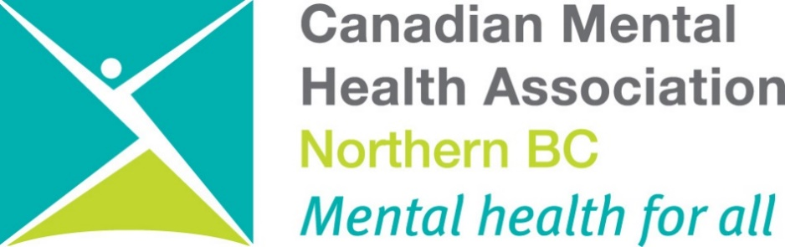

ANNUAL REPORT 2020/21

***Mentally Healthy People in a Healthy Society***

**Mission Statement**

*The Canadian Mental Health Association (CMHA) Northern BC Branch exists to promote the mental health of individuals living within the Prince George and surrounding area and support the resiliency and recovery of people experiencing mental illness.*

**Table of Contents**

**Introduction**

President’s Report

Executive Director’s Report

Program Manager’s Report

Manager of Education and Project's Report

Overview of Statistics

**Programs**

Bounce Back: Reclaim your Health

CMHA Housing

Connections Clubhouse

Employment Support & Mosaic Employment

Forensics Life Skill Program

Forensic Peer Support

Housing Outreach

Life Skills Outreach

Little of This N Little of That

Mental Health and Policing Project

New Directions Housing

Peer Support

Peer Support Northern

Public Education

Quesnel Clinical Services

Quesnel Food Recovery

Second Chance Thrift Store

Two Rivers Catering

Vocational Support Services & Mosaic Employment

**Events & Projects**

Mental Health Week

Depression Screening/ Beyond the Blues

Ride Don’t Hide

Holidays of Hope

Walk & Talk the Peace

Walking for Wellness

HML Counselling

Covid 19 and Student Health

Psychiatric Ward Peer Support Booklet

**People of CMHA**

Board members

Staff

Volunteers

**PRESIDENT’S REPORT**

Hello all,

Another year has passed, and like in years past, we welcomed some new people to CMHA of Northern BC and said goodbye to others. This was also another year dominated by the COVID-19 pandemic, but the branch continues to adapt and thrive.

Ride Don’t Hide had to be cancelled this fiscal year due to Covid but during this year, the Clubhouse rebuild was also substantially completed. There are a few minor things to touch up around the facility, though it is in use. We as a branch look forward to doing a grand opening and welcoming more people to the beautiful new building when health guidelines/orders indicate that it can be done safely.

Last, but certainly not least, on behalf of the board, I would like to thank the staff at the branch for their continued level of high service delivery and dedication to clients in these trying times.

Kind regards,

Jeffrey Wayow

President of the Board

CMHA of Northern BC Branch

**EXECUTIVE DIRECTOR’S REPORT**

2020/21 has been a year unlike anything any of us have seen. Covid 19, the opioid crisis, and fire season have impacted our work and how we delivered our work for the whole of this fiscal year. We have escaped being a site of the pandemic at the time of writing this report - which is wonderful. We have witnessed our client’s resiliency but also unfortunately witnessed the decline and even death of some of our clients - very difficult and traumatic experiences for all who were close. It has also been quite difficult to maintain patient with so many plans that had to be put on hold and remain on hold.

I am so proud of our staff who have rolled with all the changes and the limitations required. As programs were deemed essential services, staff learned the value and challenges of remote work, while others had to contend with masks, sanitizing vehicles and sneeze guards in their vehicles, which definitely changed the communication patterns with our clients.

We are tired but committed to continuing to work towards better mental health for all. We have witnessed the completion of our Clubhouse and are deep into the planning for operations once Covid restrictions lift. Each program has so much to be proud of during this past year and those points will be highlighted specifically in their reports that follow.

The plus side of Covid saw the significant influx of programming and supports for management of Covid impacts. This included our CAI funds to provide direct counselling services to our clients - many of whom had not experienced therapy in the past and were able to commence learning how to breathe effectively for stress reduction, how to ground themselves in times of stress, and how to begin to address some of the issues that kept their growth limited. We received funding to support our Covid costs - costs that initially exceeded $1,000 a month. We now have a room dedicated to hand sanitizers, masks, full clothing covers, shields and gloves.

I also want to acknowledge a program that didn't miss a beat and actually grew significantly during Covid and that was Two Rivers Catering—the preparation of meals for the ASAP shelter and frozen meals for our clients who were home bound was absolutely lifesaving and so appreciated. Allen and his crew did an amazing job of maintaining safety and continuing to provide essential services.

Quesnel programming also continued without missing a beat and our counselling program is and has become even more essential as Quesnel continues to be impacted by all the traumas and losses that are magnified in such a small community that has been so hard hit during this time period.

I want to thank all our dedicated staff and volunteers who continue to give their all to making changes big and small in the lives of people impacted by mental illness/addictions and those who love them. The following reports highlight the successes! The world is changing and stigma is lessening. We still have a ways to go, but we are walking in a world that is showing more compassion and understanding. Covid has leveled the playing field in so many ways that we will be building on as we move forward.

Maureen Davis MEd

Executive Director

**PROGRAM MANAGER’S REPORT**

This position has undergone changes in the 2020/21 fiscal year and we thank staff for their patience as these changes unfolded. This position was filled by Belinda Davidson who is on leave and then Mary Lu Spagrud who filled in while we determined next steps.

All of our staff have been under significant pressure through this Covid year and we are so proud of the fact that the majority of staff have weathered the storm with grace and good self-care. The focus on clients and client welfare has been uppermost for all and the fact that our clients have made it through so far is a testament to all the hard work and care that staff have put in to supporting our clients through this very trying time period. We have had to say goodbye to a few of our clients whom we lost under both predictable and surprising circumstances - these losses always weigh heavily on staff and other clients and we will remember these individuals as we move forward in our work. We hope to have this position filled in the new fiscal year and look forward to more stability in our management team.

**MANAGER OF EDUCATION AND PROJECTS**

Covid had huge impacts on this program following a year of significant growth and recording our first profit in this program in 2019/20. It was with great sadness that the new fiscal year 2021/22 saw the resignation of Mary Lu Spagrud who was the key presenter and face of this program. Mary Lu resigned in May of 2021 after almost 15 years with CMHA of Northern BC. She served in a number of roles and took over as full time Manager of Education and Projects and solidified its presence in the Northern Health region. Her contribution to CMHA is felt throughout the province and she will be greatly missed! Thank you, Mary Lu.

**CMHA of Northern BC All Programs Analytics**

**~April 2020 – March 2021~**

**Appointments in all programs – 5,167**

**Clients Age & Gender**

The average age of our clients between April 2020 – March 2021- 47.3 years

**Reported Primary Mental Health Condition**

**April 2020 – March 2021: 158 Patients**

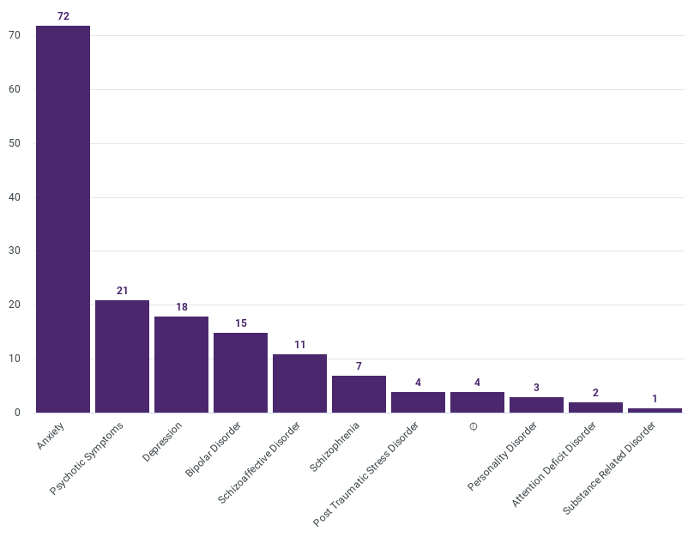

We are not yet able to pull a comparison of secondary mental health conditions, but the majority of our clients have two or more diagnoses and a significant percentage have coped by use of substances which is not reflected in this primary mental health conditions chart.

**Client Goals**

**~April 2020 – March 2021~**

Goal development during this Covid fiscal year meant that many of our client goals were very much put on hold and the focus was primarily on supporting individuals through the isolation. However some clients did move forward and achieve goals that helped to stabilize and improve the impact of their mental issues on their lives and relationships.

We had 616 documented contacts who were individuals who were not registered clients with CMHA but are typically served through our front desk. As our reception and office were closed due to Covid the number able to reach us was greatly reduced. We look forward to the day when we can once again provide direct service to people who wish to walk in to our service and gather information that will assist them and those they care about.

**PROGRAMS**



**Bounce Back: Reclaim Your Health**

**Funded by Ministry of Health**

Bounce Back continues to be a valuable provincial program providing phone coaching services to individuals who are experiencing mild to moderate anxiety/depression. This program is based on Cognitive Behavioral Therapy techniques.

We serve the entire Northern Health region with a team of 2 coaches and .4 scheduler.We were provided with surge funding to bring on one more coach and a further .2 scheduler expansion to assist with the increased demand via Covid. Covid regulations also meant we were unable to do our usual road trips that ensured adequate connections throughout the Northern Health region and relied on postal service to deliver materials and provide updates and reminders about program services. In addition to the data below, we would like to give a snapshot of the volume of materials that we are distributing in our region.

Referral numbers for 2020/2021 for Bounce Back

|  |  |  |  |  |
| --- | --- | --- | --- | --- |
| Referral Type | Referral Target/Month | Referral Target/Quarter | YTD Total Referrals | Referral Target/Year |
| All | 37 | 112 | 396 | 446 |
| Adults (65+) | N/A | N/A | 36 | N/A |
| Adults  (25-65) | 30 | 89 | 293 | 355 |
| Youths  (15-24) | 8 | 23 | 67 | 91 |

**CMHA Housing**

**MOSS HOUSE**

CMHA of Northern BC continues to operate a subsidized housing program for individuals with severe and persistent mental illness. Moss House is a 5-bedroom home that is occupied by 5 men throughout the year. It is a residential setting for those individuals to live in a safe neighborhood and have great interactions with neighbors. Also, having a family like environment has provided opportunities for social and group interactions. Our two cats Sasha and Charlie continued to thrive in this home.

We had one individual move out of Moss during the 2020/21 fiscal year and he moved back with his home community and family. We did not fill the vacancy until the next fiscal year in order to complete painting and repairs.

**Connections Clubhouse**

**Funded by CFIF and Sales**

Connections Clubhouse was a social / recreational program of CMHA. Membership was open to anyone having lived experience with mental health & addiction issues. In addition to the recreational activities, Connections Clubhouse also provided affordable lunches during the week prepared by Two Rivers Catering.

As of August 16th 2018, our clubhouse burned down and through a long and sometimes arduous process we are thrilled to be able to say that the building is now rebuilt and we are in the process of re-opening (based on Covid restrictions). The new Clubhouse will be offering a very different service level as we orient to being a Recovery College providing increased peer support services, educational groups, vocational supports and more limited recreational and social opportunities.

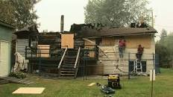 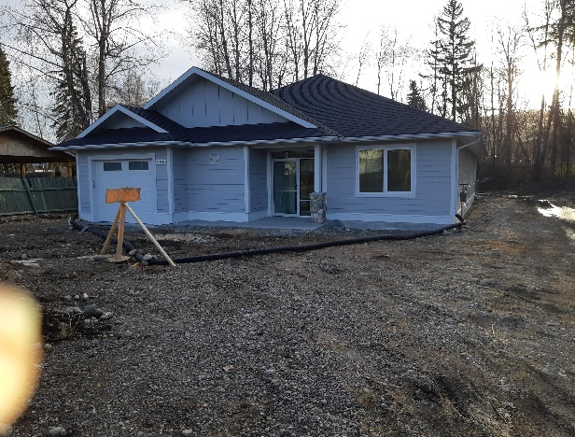

We continued to operate our Clubhouse at Aboriginal Housing who provided us with a home while ours was being rebuilt. The clubhouse operations though had to close for the bulk of the fiscal year due to Covid restrictions. Staff of CMHA ensured that the membership was provided with touch base phone calls and frozen meal supports during this time period.

We want to extend our gratitude to all who supported this development and look forward to the operations of the new Clubhouse and in particular the Recovery College work that will be commencing and will have us join CMHAs Canada-wide who are ensuring this initiative is available in our work.

**Employment Supports and Mosaic Employment Services**

**Funded by CLBC**

This is an employment support program that provides life skills and employment support for CLBC referred clients. Our goal is to assist clients with neurological, developmental and/or physical disabilities who are also impacted by mental illness/addictions, to live and work successfully in the community by determining appropriate care and interventions to meet individual needs and situational requirements.

Our staff continued to maintain connection and work with the individuals assigned on a weekly basis. This was a tough year in that very little was moving forward and we received no new referrals during the Covid time. With a new analyst coming on board, we began the work of adjusting into both employment and outreach work.

Although group work was not feasible during Covid - many of our CLBC clients commenced therapy with HML services (Covid funded therapy program) which saw some significant improvements in their lives and helped ensure stability in the year.

**Employment Support Appointments**

**~April 2020 – March 2021~**

Total Appointments: 600

**Employment Support Client Age & Gender**

**~April 2020 – March 2021~**

The average age of our Employment Support Clients from April 2020 – March 2021:

30.6 years

**Forensics Life Skill Program**

**Funded by Forensic Services**

The Forensics Life Skills Program works with a wide range of individuals who are referred by Forensic Psychiatric Services Commission (FPSC). This full-time position is giving individuals living with mental illness and/or addictions who have been in conflict with the law more support in maintaining stability and moving towards independent living. The Forensics Life Skills program provided training to 6 clients in the areas of budgeting, personal hygiene, grocery shopping, bill payments, medication pickup, medical appointments, and ongoing support with securing housing.

As with all our programming, the forensic life skills client is also working towards the long-term goal of reintegration into community with zero recidivism. Within that large goal are many smaller objectives that are celebrated upon achievement with the setting of new objectives once previous ones are successful.

Covid also hit this program hard with no real ability to keep moving folks forward in health goals. So, the focus became keeping people stable and as healthy as possible. For some people that meant daily contact either in person or by phone while for others that meant weekly or biweekly contact. As most know, the prison and court systems were heavily impacted by Covid and many people who would have been incarcerated were actually left in community because the prisons were not accepting any new residents during the heavy Covid periods. Consequently, court was also delayed—for some, court sentencing was delayed close to a year.

**Forensic LifeSkills Appointments**

**~April 2020 – March 2021~**

Total Appointments: 592

________________________________________________________________________________________________________

**Forensic Lifeskills Client Gender & Age**

**~April 2020 – March 2021~**

The average age of our Forensic Life Skills patients this year:

41.7 years old.

**Forensic Peer Support**

**Funded by Civil Forfeitures of BC**

Unfortunately, we were unable to find funding to continue this vital program so have had to shut down the program as of May of 2021. The success of this program is specifically highlighted in the example of one participant who we continue to support under the auspices of life skills. This individual was released on the courthouse steps with no housing, no medication and no support beyond what was arranged with CMHA. We have helped her to navigate to permanent housing, support with her children, gaining appropriate medication and health care provision. The stresses we have supported her through could easily have invited her into relapse positions and re-entry to jail but instead she is on her way to a family treatment program with her children and a sense of hope for her life.

We believe this level of support is essential for all those individuals leaving the prison setting and unfortunately this level of support is rarely available. We hope to find funding or even a research project that could allow us to reactivate this program and find a way to make it a permanent resource in Prince George.

**Housing Outreach**

**Funded by City of Prince George and the United Way**

Resource Housing Outreach is a 16 hours per week part time position assisting people who are experiencing mental health concerns access affordable and safe housing in the community. In 2020/21, an average of 30 people had appointments for information on services and/or assistance per month. As our main office remained closed to walk ins during Covid, people had to make appointments which certainly added a barrier for those who wanted to walk in. Screening for Covid practices occurred to ensure safety for staff prior to building entry.

The HIP committee (Homelessness Intervention Program) continued to meet in person or virtually, but found that its ability to provide the essential services was severely impacted during Covid, resulting in fewer and fewer agencies in attendance and able to offer assistance. As a result, our Housing Outreach staff relied on their own connections to help move things forward for clients and successfully housed 30 individuals.

Due to Covid, no Ready to Rent (Rent Smart) courses were able to occur, and we look forward to the day that this course can recommence providing the following:

* Tenant and Landlord rights and responsibilities; living effectively with others, communication skills, budgeting and planning for stability, maintenances dos and don'ts, crisis management, safety and pests.

**Appointments**

**~April 2020 – March 2021~**

Total Appointments: 102

Completed: 97

No Show: 2

Cancelled: 3

**____________________________________________________________________________________**

**Housing Outreach Patient Age & Gender**

**~April 2020 – March 2021~**

Average Age: 42.5

**Life Skills Outreach**

**Funded by Northern Health**

The Life Skills Program continues to play a vital role for CMHA Prince George and the people we serve. Life Skills provides one-on-one support to individuals with mental health/addiction concerns to achieve independent living within community. Our Life Skills team is comprised of 4 full time staff providing services to individuals who are referred by Northern Health staff, family doctors or other agencies and supported self-referrals.

We deliver services seven days a week - 365 days a year and in 2020/21 we served 49 unique individuals with different goals and objectives designed to help them achieve stable mental health. The types of services provided can be budgeting, self-care, home maintenance, hygiene, communication skills, physical health improvements, increasing social supports etc. We work in partnership with any other support people involved in the individual's life. We work on assisting people to uncover underlying issues that might be contributing to the presenting problems such as social anxiety, generalized anxiety, depression etc. Participation in case conferences with the individuals we work with is an important element of the overall case planning that takes place.

This year brought significant changes due to Covid. During the initial lockdown period, our work focused on weekly check ins via the phone. As restrictions began to ease we were able to again have face to face visits, typically outside with social distancing.

We also provided free frozen meals to clients who were struggling to leave their home for groceries and assisted with other issues that were occurring due to the anxiety increases from Covid. Our goal work changed for many clients as we focused on assisting them with maintaining their mental health under the extraordinary isolation that was now a reality in their lives.

**Life Skills Appointments**

**~April 2020 – March 2021~**

Total Appointments: 2,215

**Life Skills Clients Gender & Age**

The average age of this year’s life skills clients are:

51.5 years old.

**Little of This N’ Little of That**

‘Little of This N’ Little of That’ was a low-cost canteen-style store operating out of Connections Clubhouse from 9am -1pm Monday to Friday. This store provided affordable, individually packaged, single served goods for people who live on a fixed budget and can’t always afford to buy groceries in bulk. Groceries were purchased in bulk then divided and individually packaged. The store served as a training site in the Vocational Program for individuals living with mental health and addiction issues where they could volunteer and develop new job skills. Due to both the fire and Covid, this store has not re-opened.

**Mental Health and Policing Project**

**Participant Time Donation Only**

This project is designed to improve responses by police officers and other first responders to people with mental illness in crisis. Through the involvement of RCMP, people with mental illness, their family members and crisis services such as the BC Ambulance Service and related mental health services including NHA, and community agencies, work is occurring to identify strengths and areas for improvement in our interactions with people experiencing a mental health crisis. Due to Covid, there was no activity within this project at our local level. There is significant activity at both a provincial and national level as there is more and more understanding that the current in house RCMP training is insufficient. Negotiation is occurring around redevelopment of mental health training in-services for first responders and our program is being considered as a model of excellence.

**NEW DIRECTIONS HOUSING**

**Funded by BC Housing and Residents**

CMHA operates 19 BC Housing subsidized housing units for persons with severe and persistent mental illness. Subsidized units are located throughout Prince George (see map below) in various apartment buildings which provides individuals with safe and affordable housing. This position is 5 hours per week.

The New Directions role is to:

1. Intake for applicants and find housing to meet client’s needs.
2. Develop and maintain connections with landlords and tenants.
3. Resolve housing issues such as repair and maintenance concerns to landlords.
4. Submit all yearly evaluations/rental increases to BC Housing.

Life skills picked up individual support for some of our tenants as 5 hours a week did not allow sufficient time for our New Directions staff to stay in contact with 19 individuals during Covid. We had two individuals leave our subsidized programming because they now qualified for SAFER, allowing us to rent to two other individuals impacted by mental illness. Although we technically do not have the responsibility for the two individuals now on SAFER, we have continued to support them through Covid 19.

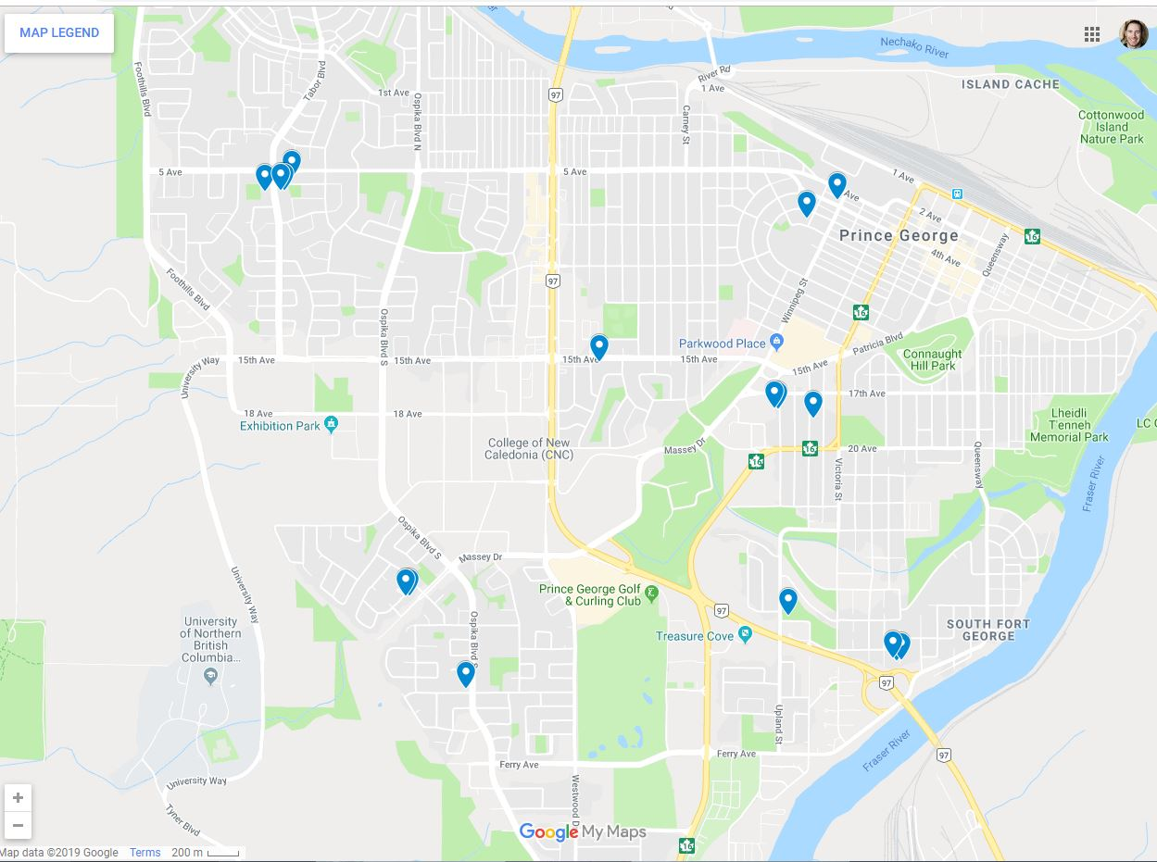

**New Directions Appointments**

**~April 2020 – March 2021~**

Total Appointments: 102

Completed: 90

No Show: 11

Cancelled Count: 1

**New Directions Client Age & Gender**

**~April 2020 – March 2021~**

The average age of a New Directions client from April 2020 – March 2021:

51.1 Years old

**Peer Support**

**Funded by Northern Health**

Peer Support is a well-researched model of service delivery where a peer with lived experience of the mental illness/addictions and recovery process provides mentorship and support to another individual faced with a similar path of recovery. The **Peer Support Program** (.6FTE) provides a variety of activities to help mental health consumers, both in office and outreach in the community. Covid changed the picture for us significantly and the bulk of our peer support work has been channeled to those impacted by the opioid crisis and the homeless population outside our front doors. Overall the program has served 46 individuals with a wide variety of needs. The concerns of those who are unhoused continues to be a polarizing issue in our community and we continue to provide support to those individuals who are often targeted for significant harassment and discrimination.

The **Positively Peer Program** and **One on One Program** provide support and community resources to patients on the psychiatric unit at the hospital. Due to Covid and hospital lock down resulted in no contact with patients on 3NE. We asked for posters and information sheets to be left on the unit but very few calls were forthcoming.

**Keeping in Touch program (KIT)** provides phone support for individuals who have left an institutional setting and can benefit from a supportive weekly phone call to help with transition. This program was maintained through Covid but information on those released was not forthcoming, so we only maintained contact with people already on our call list.

**Peers Prospective Newsletter**. Due to Covid, this newsletter was not published

**Peer Support Appointments**

**~April 2020 – March 2021~**

Total Appointments: 381

Completed: 308

No Shows: 7

Cancelled Count: 3

**Peer Support Client Age & Gender**

**~April 2020 – March 2021~**

The average age of our April 2020 – March 2021 peer support clients:

43.8 Years old.

**Peer Support Northern BC**

**Funded by CMHA BC Division**

With some funds from BC Division, we were able to fund a line and some hours of peer support coverage. Unfortunately, the line was not utilized enough and it is clear that advertising is going to be critical for moving forward. We hope to be addressing these issues shortly. We do have several communities interested in providing peer support services in their communities and several individuals have been trained through the Nova Scotia Peer Support Training and are ready to commence work when Covid is more resolved.

As well, we have commenced a partnership with OSI-CAN to provide the financial funneling and support to Ron Blinn who is the Northern BC Representative for OSI-CAN. OSI-CAN is the body that provides peer support services to first responders—RCMP, retired military, fire Departments, paramedics, and Wildfire fire fighters.

**Public Education**

**Funded by Sales and Gaming Funds**

Our Public Education program took a large hit through the past fiscal year with significant reduction in workshops presented and many last-minute cancellations as we navigated the ongoing changes in health orders. It was also a year of technology as we learned how to navigate the world of virtual training—the etiquette rules, the breakout rooms, and the ongoing cry of "you are on mute". Nonetheless, we did some valuable work and trained new staff in presentation skills, and we anticipate that once Covid retreats, the demand for this program will skyrocket and we feel prepared to meet that challenge.

_______________________________________________________________________________________________________

**Quesnel - Clinical Program**

**Funded by the Red Cross**



**You never know who will just walk in seeking support!**

Stephanie and Tracine often have different visitors arrive to the Quesnel office and these visitors were lovely! The Quesnel office was able to continue to support individuals throughout the pandemic. At times, this was accomplished by meeting virtually or over the telephone. Though the window for in person group presentations was limited; we were able to bring an MHFA and an ASIST to the community, as well as support people through virtual MHFA. We were approached by the Rotary Club of Quesnel to attend a virtual meeting where we provided psychoeducation and tips and tricks to coping with the stress of the pandemic and supporting others. The Rotary Club will be funding two MHFA in the fall of 2021, pending pandemic restrictions being lifted.

The community has faced multiple stressors, but continues to demonstrate resilience. Community resources support each other to ensure that community members are able to access resources as needed.

**Quesnel Client Age & Gender**

**~April 2020 – March 2021~**

_______________________________________________________________________________________________________

**Quesnel - Food Coordination Program**

**Funded by Private Donor**

2020/21 has been a tremendous year of growth for this program despite the Covid impacts. A three year grant was owrked on for months and has been achieved through the Vancouver Foundation commencing in September of 2021. Funding from West Mills allowed for emergency food/good food boxes to be distributed to those in need. The Quesnel Sustainability Food report was completed and can be accessed and read through

<https://northernbc.cmha.ca/community-food-coordination-program/>.

Quesnel has been struggling to cope with all the impacts from fires, permanent mill shutdowns and a rapidly growing opioid crisis. This has strained the community significantly and then Covid 19 hit and added a layer that has really stressed the residents. The food coordination program has provided a practical assistance in community collaboration as well as support for innovative programs such as Sprouts Kitchen. The City of Quesnel has developed a large kitchen and storage space that is open for sharing with all community groups and our program will be a resident in that program in the next fiscal year.

This will allow us to move forward with becoming a distributor of reclaimed food and products for distribution to those in need. We look forward to our future growth and send a tremendous THANK YOU to Kirsten Balaski who has done so much work for this program.

**Second Chance Thrift Store**

**Funded by Sales and by Gaming for Skills Development**

Second Chance is a social enterprise thrift store which was typically open Monday- Friday 10:00 am – 4:00 pm. It provided good quality, clean items and clothes to the community at a low cost. The store relied on donations from our community to keep it stocked. Store purpose was to provide vocational training sites for individuals recovering from mental illness and/or addictions.

Due to Covid, the store has remained closed.

**Two Rivers Catering**

**Funded by:**

**Sales from Catering and Lunch Program**

**With Gaming Support for Skills Development**

Two Rivers Catering had a very successful year and maintained full operations under Covid safe restrictions. Significant changes were implemented as all meals had to be individually packaged and delivery often meant standing on sidewalks and handing food over to staff. Our partnership with Active Support Against Poverty was the main contributor to our ability to remain open in this program, as Two Rivers was hired to provide meals to the shelter.

The following indicates where our sales came from for the fiscal period:

* $152,555 from Active Support Against Poverty meal program
* 19,010 from Covid funded frozen meals program (offset by $17,600 in Covid grant funds)
* 3,780 from Pounds frozen meal program
* 1,644 from various miscellaneous orders
* 828 from Integris Credit Union
* 825 from BC Housing
* 480 from Walking in Wellness Group
* 313 from Aboriginal Housing

This represented a total sales of $179,435 and a 27% sales to cost ratio which is well above the 35% standard that is aimed for.

$40,000 from Gaming continued to provide the essential funding to support the clients who work at Two Rivers Catering to ensure they have the support and guidance they need to do a great job. A year of no injuries and 2 individuals moved on to work in the restaurant industry part-time and 1 individual moved into a full-time construction position.

**Vocational Support**

**Funded by Northern Health**

The Vocational Support Program typically works in collaboration with Rehab Services of Mental Health and Addictions, Northern Health. The Vocational Support Programs goal is to assist clients that live with mental illness and / or addiction issues in developing vocational skills. By developing employment readiness skills individuals can improve their chances of success as they work toward finding paid employment, volunteer positions or educational opportunities in their area of interest. CMHA has 2.6 FTE vocational staff.

Covid presented significant challenges as employment was simply not possible during Covid and the result was that staff spent their time providing support and encouragement to the Vocational clients. Focus was to maintain the skill level achieved prior to Covid and ensure readiness for re-entering the employment field once Covid restrictions lifted. Northern Health vocational and recreational services were suspended throughout the pandemic, so we made sure the clients had food, helped them with shopping, and checked in with those who weren’t comfortable leaving their homes and supported these clients with their increased anxiety with the isolation. We provided outdoor recreation via a very popular walking group, which continued through the winter. During this time, we had two clients who contracted Covid and our support continued by checking in with them on a daily basis, delivered meals and meds when needed.

**Vocational Support Appointments**

**~April 2020 – March 2021~**

Total Appointments: 572

Completed: 568

No Shows: 1

Cancelled Count: 3

**Vocational Support Client Gender & Age**

**~April 2020 – March 2021~**

The average age of the Vocational

Support Patients is: 52.3 years old.

**EVENTS & PROJECTS**

**Mental Health Week**

**May 4-10, 2020**

Covid invited us into a new process of virtual work during this week.

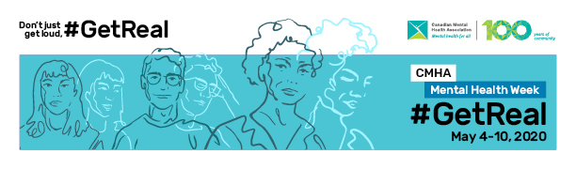

We relied heavily on the media toolkit provided by CMHA National and did several media interviews as well as broadly promoting social media to inform about the self-care needed during the pandemic.

**Depression Screening/ Beyond the Blues**

**February 9, 2021**

This was another exciting and fulfilling day with our partnership with University of Northern British Columbia – Margaret Fuller with the First Nations Centre and the School of Social Work. Again, a complete change in process with a virtual delivery of and event from 2-6 pm that provided speakers about self-care and the resources available in the community combined with the ability to conduct mental health screens virtually in break out rooms. Although only attended by less than a dozen people with screens completed by only 2 people, those who attended enjoyed the event and our presenters in particular talked about how thrilled they were to connect with one another and share their experiences.

The presenters were:

***Marcel Gagnon*** who provided a traditional welcome and shared his music.

***Dr Tina Fraser*** - Associate Professor and Acting Chair of School of Education and First Nations at UNBC - who shared her personal and Maori experiences of self-care

***Erin Anderlini*** - Director of Health Native Friendship Centre who shared her self-care and the resources available at NFC

***Andrew Kurk*** - Epidemiologist Northern Health - who discussed pandemic self-care

***Sandra Boulianne*** - Executive Director of Crisis Lines of Northern BC who discussed reality of crisis line use during pandemic and resources available

***Shirley Hogan*** - Program Manager CMHA who discussed pandemic care and resources in community

***Jane Gagnon*** - Wellness Coordinator YMCA who discussed programs available to community

***Sandy Galletti*** - Foundry Clinical Therapist who discussed available programs at Foundry

Much thanks to Lory Moroz and Nicole Antonenko (CMHA Bounce Back staff) who also made themselves available to conduct wellness screens along with several UNBC practicum students. Although not needed, it was wonderful to have them in attendance.

**Ride Don’t Hide**

**June 7, 2020**

**Cancelled due to Covid**

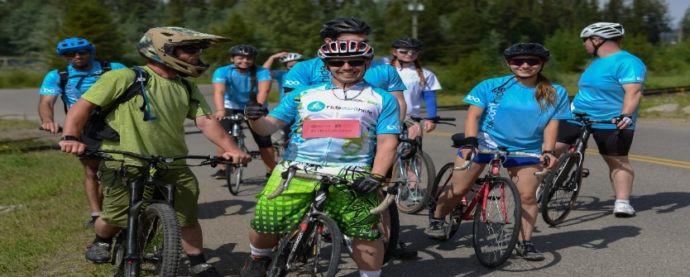

**Holidays of Hope** - **December 2020**

Due to Covid, we had an entirely different event this year. We did ask people to register any children they wanted gifts for but otherwise CMHA and ACE (Activity Centre for Empowerment) made a decision that moving forward we would only focus on our own clientele. We provided gift cards and frozen turkey dinner to all our clients as well as gift bags for children they applied for.

We raised $8,731 in donations and spend $8,674 in gift cards and frozen meals. Our clients expressed gratitude for what was provided to them and fully understood the inability to get together due to Covid.

_________________________________________________________________________________________________________

**Walk & Talk the Peace - August 20-28, 2020**

Stan Fraser, a local man from Chetwynd, set a goal to do something extraordinary to help get the conversation started and end the silent suffering from mental illness.  On August 20, 2020 Stan embarked on a walk from Fort Nelson and stopped in communities along the way on his return back to Chetwynd.  Gatherings occurred in remote communities to campaign for mental health awareness and advocacy, spreading the word about where to find the care that is needed to save the lives of those who suffer in silence. Stan raised $4,045 for CMHA of Northern BC to assist in our Public Education Program. Lory Moroz and Nicole Antonenko travelled to Chetwynd to provide an info booth and accept the funds on our behalf and honor his achievement!

_____________________________________________________________________________________

**Walking for Wellness - September 15 - October 27, 2020**

This was a 6-week trail walking clinic for women designed to enhance mental and physical health. Group members safely explored trails in Prince George, BC while connecting with fellow community members and improving their mental wellness. This clinic was led by a registered clinical counselor and physical education professional Sue MacDonald (On the Ground Consulting and Counselling) with a group of experienced trail walkers.

30 women attended and completed this event with rave reviews. This program was funded by a generous grant from the City of Prince George combined with sales from participants able to afford the registration. Two women were subsidized to attend this program and one of our Life Skills workers Cheryl Young provided much needed support to one of those women.

_____________________________________________________________________________

**HML Counselling – May 9, 2020 to March 31, 2021**

We were so thrilled to be accepted by Community Action Initiative to receive funding to provide counselling services to our clients. We were then able to contract with HML Counselling (owner Tracy Larson) who was able to quickly commence services to CMHA clients and hence have additional supports (by phone, virtual or in person) to manage the impacts of Covid as well as the fact that many of our clients have been unable to access therapeutic interventions despite their mental health concerns. In this period of time, 36 of our clients received 352 counselling sessions. It has provided regular and timely support for the day to day struggles our clients were dealing with as a result of schizophrenia, bipolar, anxiety, depression, etc. and also supported family members and friends and attended case conferences for essential planning. Our staff who had been the primary supports also noted how beneficial it was for them to have increased support in their work and to seeing increased growth with clients who had previously had limited goal development in the past.

_____________________________________________________________________________________

**Covid 19 and Student Health**

With support from CMHA BC Division via Youth Bounce Back programming, our staff member Katherine Paul did some exceptional work putting together a recovery from Covid manual for high school students. This 17-page booklet will be distributed to classrooms throughout the Northern Health region in September of 2021.

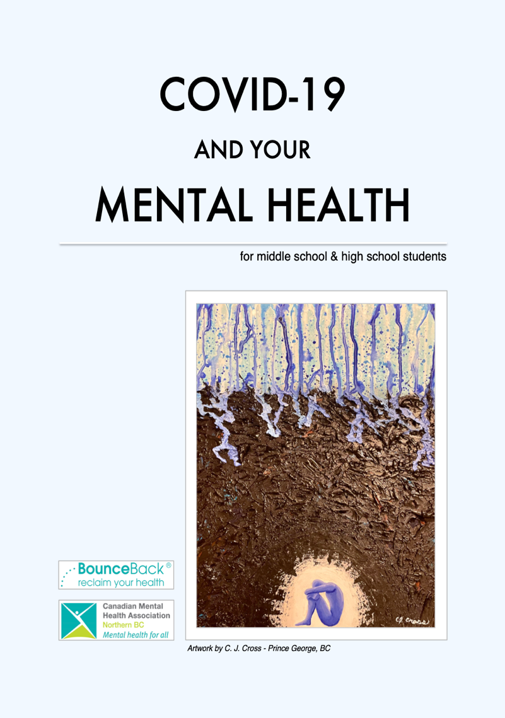

**Psychiatric Ward Peer Support Booklet**



This booklet for use on the adult psychiatric ward has been in the works for many years as a collaboration with Northern Health. However, the difficulties with getting approvals through the legal department and the impacts of Covid 19 resulted in this coming to a halt. As a result, a decision was made to make this a document solely for use by CMHA Peer Support Workers to assist those on the unit and all Northern Health information that required legal approvals were removed. Once Covid is clear and we are allowed back into the hospital, this booklet will become standard use by our peer support workers. Many thanks to our practicum students and Katherine Paul.

_____________________________________________________________________________________

**Volunteers**

Due to Covid 19 and the agency shutting its doors to walk-ins, the volunteer program took a sharp dive. Volunteers remained active on the Board of Directors but the activities related to info fairs and booths were in sharp decline as well as the activities within the thrift store and other services as completed by volunteers. We miss you!!!

**PEOPLE OF CMHA**

**CMHA Board of Directors 2020-2021**

|  |  |
| --- | --- |
|  |  |
| Jeffrey Wayow | President |
| Orestine Ostapiuk | Secretary/Treasurer |
| Kristin Thompson  Kelly Mould | Treasurer/on leave  Secretary |
| Bryan Schultz | Director/Vice President |
| Andrew Kurk | Director |
| Glen Schmidt | Director |
| Chelsea Dunk  Elizabeth Bennet  Nadia Mansour  Adrianne Johnston | Director  Director  Director  Director |

**Staff 2020/21**

|  |  |
| --- | --- |
| Allen Zgaga  Amanda Lemky  Anita Antonenko | Chef Two Rivers Catering  Admin and Volunteer Coordinator  Casual Life Skills |
| Belinda Davidson | Program Manager |
| Cassie French  Charmaine Makelke | Life Skills  Casual |
| Cheryl Young | Vocational Support |
| Clara Orr | Front Reception |
| Devin Sluchinski | Peer Support Northern |
| Ed Lui | Peer Support/ Forensic Peer Support/on leave |
| Felix Okorafor | Employment Support Worker |
| Heidi Wilson | Life Skills/Vocational |
| Jessica Zaporozan | Life Skills |
| Jeannine Glowacki | Resource Housing/Life Skills |
| Jeff Hodson | Life Skills |
| Jennifer Carter | Admin Assistant/Volunteer coordinator/on leave |
| Jenny Malyk | Life Skills |
| Kama Katrinchuck  Katherine Paul | Employment Support Worker  Executive Assistant |
| Kiran Bassi  Kirsten Balaski  Lin Bai | Employment Support Worker  Food Coordinator Quesnel  Accounting |
| Lori Ann Ryser | Peer Support Northern |
| Lory Moroz | Bounce Back Coach |
| Marie Bradley | Vocational Support |
| Mary Ellen Johnson | Forensic Life Skills |
| Mary Lu Spagrud | Manager of Education & Projects |
| Maureen Davis | Executive Director |
| Nada Peters | Resource Housing/Peer Support |
| Nicole Antonenko  Shauna Russell  Shirley Hogan  Stephanie Aaslie  Tyler Leary | Bounce Back Coach  Forensic Peer Support/Executive Assistant  Program Manager  Clinical Coordinator Quesnel  IT |
|  |  |

**Thank you**

**We appreciate all you do for**

**and with us!**