{"a":5,"d":"B","h":"www.canva.com","c":"DAFKKDwcSiQ","i":"u2MrBJ0_2ckjSkGXFx_xxA","b":1661273677266,"A?":"B","A":[{"A":32.39999999999981,"B":-27.081762356487957,"D":1048.281762356488,"C":521.6,"A?":"I","a":{"B":{"A":{"A":"MAEC5Au7oxA","B":1},"B":{"A":-88.6272541188294,"D":1048.281762356488,"C":698.8545082376587}}}}],"B":940,"C":788}

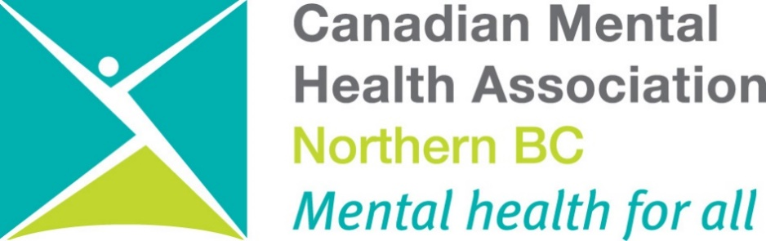

ANNUAL REPORT 2021/22

Mental Health is a Universal Human Right
Mission Statement
The Canadian Mental Health Association (CMHA) Northern BC Branch exists to promote the mental health of individuals living within the Prince George and surrounding area and support the resiliency and recovery of people experiencing mental illness.

Table of Contents
Introduction
President’s Report
Executive Director’s Report
Program Manager Reports
Manager of Education and Project's Report
Clinical Coordinator
Overview of Statistics

Programs
1201 1st Ave
Bounce Back: Reclaim your Health
CMHA Housing
Connections Wellness Centre
Employment Support Outreach & Mosaic Employment
Forensics Life Skill Program
Forensic Peer Support
Housing Outreach
Life Skills Outreach
Little of This N Little of That
New Directions Housing
Peer Support
Peer Support Northern
Public Education
Quesnel Clinical Services
Quesnel Food Recovery
Second Chance Thrift Store
Two Rivers Catering
Vocational Support Services & Mosaic Employment

Events & Projects
Mental Health Week
Depression Screening/ Beyond the Blues
Ride Don’t Hide
Holidays of Hope
Walking for Wellness
HML Counselling
UNBC Student Wellness

People of CMHA
Board members
Staff
Volunteers

PRESIDENT’S REPORT

Hello everyone,
It has been another eventful year at the CMHA of Northern BC Branch.
The branch, like the rest of the world, has been focused on service delivery in the continually changing COVID world. It has been good to see some programs safely return to in a person format. We are hopeful that we can safely return to pre-pandemic delivery on all programs soon; subject to provincial health authority recommendations/directives. Both staff and clients have continued to rise to the challenges posed by the pandemic.
A highlight for the board was the long-awaited completion of the clubhouse. All of the finishing touches were put on the clubhouse during the fiscal, and it should serve the branch well for many years to come. It was great to see the impressive community turn out that occurred just after this fiscal year.
A thank you goes out to the donors, volunteers, staff, management, board members, and community members that contributed to this year’s successes during another challenging year. Without the determination of donors, volunteers, staff, management, board members, and community members we would not have been nearly as successful.

Last but not least, on behalf of the CMHA community, we would like to thank Maureen Davis, the Executive Director for her service. Maureen is retiring after over a decade with CMHA of Northern BC (and its various iterations). Though she is retiring after a long and distinguished service, I suspect that you will see her around the office and at CMHA events in the very near future.

The Board of Directors would also like to formally introduce Maureen’s successor, Sarah Lloyd, to the CMHA of Northern BC community. Sarah joins us after retiring from a long and fulfilling career at the executive level with the BC Public Service.

Jeffrey Wayow
President of the Board
Canadian Mental Health Association of Northern BC Branch

EXECUTIVE DIRECTOR’S REPORT

2021/22 has been a year that continued to challenge our strength and resiliency as Covid continued on and we dealt with a couple of mini outbreaks that reminded us it was still with us! I am so proud of our staff who have rolled with all the challenges and the limitations required as well as the successes that continued to be witnessed in our work.
We are tired but committed to continuing to work towards better mental health for all including increased support for our staff. We have done well with staff retention during this period despite the sense of overwhelm that is impacting all our work. Our 5 year strategic plan has seen some significant early achievements and then some delayed work primarily due to Covid.
We continue to reap benefits from Covid in the sense of increased funding but we also saw the impact of 3 years of Covid on our clients and the growth that had been lost as Covid restrictions lifted and we began encouraging people to come out and rejoin our activities.
Two Rivers Catering continues to enjoy record breaking years of work and a team that has continued throughout Covid and never missed a beat. Allen's crew has grown by 1 more chef as we commence expansion into new programming.
We made a big step with reworking some staff positions in order to have a Wellness Coordinator - a position filled by Cheryl Young who has been working very hard to get Connections back up and running as well as expansion into Recovery College and more community involvement.
Public Education has also been extremely busy and we have learned a lot about use of virtual platforms to provide essential education to reduce stigma and increase comfort and expertise in working with individuals impacted by mental illness and addiction.
We put a lot of work into two projects - one for the development of services at LNG sites and we were not successful with this bid. However, our partnership with Active Support Against Poverty for the development and operation of 1201 1st Avenue Supportive Housing was successful and we were informed on BC Housing approving our bid in early 2022.
I want to thank all our dedicated staff and volunteers who continue to give their all to making changes big and small in the lives of people impacted by mental illness/addictions and those who love them. The following reports highlight the successes! The world is changing and stigma is lessening to some degree - an opportunity for us to expand and educate.
Maureen Davis MEd
Executive Director

PROGRAM MANAGER’S REPORTS
Our Life Skills Program has had some challenges with support services for clients as restrictions even as began to lift. Services had begun to open up however there seems to be staff shortages everywhere after the disruption in mental health services during Covid. There have been doctors/psychiatrists that have left within the year as well that had left some clients without a psychiatrist until they were assigned another.
The food banks were being utilized by many clients and they were struggling to keep up with the demand for food hamper requests. There was a limit placed on the number of spots available for food hampers. Fortunately, our clients’ hampers were available to them although the supply was more limited.
There has been some Life Skills clients who have had considerable progress with their goals. For example, a client who had great difficulty passing their housing inspections and was facing the possibility of eviction has been able to successfully pass her inspections monthly without the ‘hip to hip’ support of a life skills worker. She is also comfortable and confident enough to have the inspections take place when she doesn’t have a life skills worker or other support persons present.
Moss House residents have done well through the 21/22 year and we have escaped any Covid outbreaks.
Our Vocational Program has continued to be impacted by Covid through the 21/22 year but as covid restrictions lift and the reality of insufficient workers occurs we will have opportunities to have our clients employed in meaningful occupations.
Chris Habsburg,
Program Manager

My name is Nada Peters and I accepted the other Program Manager position literally at the end of the 21/22 fiscal period on March 20, 2022. This position is the successful strategic plan process of ensuring that the Executive Director is no longer providing direct line supervision to staff. As a result, I am responsible for the ESW/Outreach team. Our IT staff person, Front reception and Second chance Thrift Store, New Directions Housing and Housing Program, Peer Support and Outreach Peer support as well as out new program on 1st Avenue.
I am adjusting to a management role and looking forward to stabilizing all the programs now that Covid restrictions are lifting and we are able to start focusing on the strategic plans for each program. This position has been vacant since the leaving of Belinda Davidson and was covered by our ED Maureen Davis
Nada Peters
Program Manager

MANAGER OF EDUCATION AND PROJECTS

As in previous years the requests for education continue to grow and we have become a go to for mental health education in Northern BC. I took over as Manager of Education and Projects in May of 2021, when the previous manager resigned, and have not had a second to look back! CMHA continues to be a go to for agencies looking for staff and/or client training. This past fiscal our education program has facilitated in school settings from elementary school children to college level staff and students. We have provided education and training to both the public and private sectors.
COVID certainly had an impact on our Education Program, for many months we were unable to provide in person training. We did however, very quickly, adjust and create on line programs to ensure we could continue to meet training needs. This past fiscal year we offered Mental Health First Aid as well as many of our custom workshops virtually. Moving forward we will continue to offer both the virtual sessions as well as in person training depending on the need of the client. The requests for training continue to come in and we are offering training almost every week of the year.
We are looking forward to attending more health fairs and events as COVID restrictions continue to be lifted and in person events increase. This has historically been a positive and impactful way to share information and we look forward once again attending events regularly.
We look forward to another year of growth, changes and challenges in the coming year. We would also like to thank the Board, Management and staff at CMHA for the on-going support for our Education Program.

Shirley Hogan,
Manager of Education and Projects.

_____________________________________________________________________________________

CLINICAL COORDINATOR
The Quesnel office has been consistently busy this year. We have continued to see individuals in person, over the phone and virtually. We were able to facilitate a Mental Health First Aid that was sponsored by the Rotary Club of Quesnel where 10 people received their MHFA certificate. Through community networking a one hour course on resiliency for AXIS was also facilitated and nine people attended.
We continue to participate in committees to network and strengthen/develop community partnerships. One of these partnerships was having a social work practicum student join our office to complete their third year practicum. We also have worked with a group of community partners to bring a Situation Table to our community and continue to support our local Community Action Team
Our goal for this year is to continue to meet people where they are at in a non-judgmentally and with empathy. We know and as our statistics and feedback from community resources, partners and community members demonstrate that this office needs to stay open so securing funding to ensure this happens is another main focus of ours for the upcoming year.
Stephanie Aaslie
Clinical Coordinator

FOOD RECOVERY COORDINATOR
Food Recovery has continued to be an essential need in Quesnel through the 2021/22 year and we have had significant support from the community. In particular the West Lake Mills have contributed large sums of money to maintain the good food box program which works in partnership with Long Table Grocery to ensure that those in need can receive food specific to their dietary needs. In keeping with our philosophy this is not a program that requires people to demonstrate "need" so there is no need to show rent and utility receipts etc.
We continue to work on building partnerships in the community but it has been a bit of a struggle primarily due to Covid exhaustion and a sense of community isolation and struggle. Quesnel continue to be impacted by a great deal of trauma and as a result there has been a move towards taking "sides" and struggling to understand the views of each side. Those impacted by financial poverty have grown in numbers and the shame and judgement unfortunately has also grown.
A significant positive accomplishment has been the acceptance into a three-year grant project with the Vancouver Foundation and we are hopeful that this will ensure the stability moving forward that is needed. Huge thanks to Kirsten Balaski for her successful submission.
Corbin Bright
Food Recovery Coordinator
_____________________________________________________________________________________

OVERVIEW OF STATISTICS

~April 2021 – March 2022~

Total Appointments in life skills/outreach/vocational/peer – 7,270

Clients Age & Gender

51% of our clients identify themselves as Male, 46% as Female, and 3% as Other.
The average age of our clients in these programs between April 2021 – March 2022 is 44 years old, as you can see in our pie chart we have a very diverse age group in our clients.

Reported Primary Mental Health Condition
April 2021 – March 2022: 188 Clients

We had 188 clients receiving ongoing contracted services. We are not yet able to pull a comparison of secondary mental health conditions, but the majority of our clients have two or more diagnoses and a significant percentage have coped by use of substances which is not reflected in this primary mental health conditions chart.
Client Goals & Objectives
~April 2021 – March 2022~

Objectives established: 559 - in general clients set between 2-4 major objectives to work on in any given 12-month period.
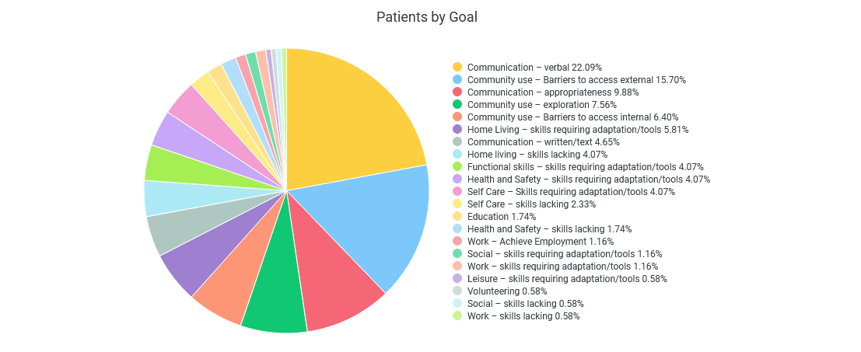
Objectives Achieved: 303

Patients by Ethnicity

Caucasian: 74 Chose not to identify: 72
Aboriginal/First Nations: 40 Asian: 2

Clients by Current Objective #1-4 Status

Goal development during this Covid impacted fiscal year still meant that many of our client goals were very much put on hold and the focus was primarily on supporting individuals through the isolation. However, some clients did move forward and achieve goals that helped to stabilize and improve the impact of their mental issues on their lives and relationships.

Non-client contacts
We had 180 documented unique contacts who were individuals who are not registered clients with CMHA but are typically served through our front desk through phone calls or walk in visits. As our reception and office were closed due to Covid the number able to reach us was greatly reduced. We look forward to the day when we can once again provide direct service to people who wish to walk in to our service and gather information that will assist them and those they care about.

This tells us that most of our non-client contacts, 66% of them where contacting us through the phone. While the lesser 34% of them where contacting us through walk-ins and speaking to our receptionist.

PROGRAMS
_____________________________________________________________________________________

1201 First Ave Residential Support

This is a new project, which came on board at the end of the 2021/22 fiscal year. It is a joint project of CMHA of Northern BC and Active Support Against Poverty and is the culmination of years of working together and having a dream of providing mental health supports within a housing project. The focus is on ASAP providing the housing supports for individuals impacted by homelessness and addictions. CMHANBC does the work of assisting people to find ways to improve their health and wellness – this could be through ensuring they have medical followup – potentially assisting with referrals for addiction treatment – helping connect with services in the community – helping reconnect with family and friends where possible – providing work based opportunities where feasible. Our philosophy is that if we can help people find things to improve their lives there might be less and less room for addictions and health destructive behaviors. Often our world asks people to give up a coping mechanism like addictions with nothing to take its place. We hope to provide options and support for people to make changes if they wish.

This facility is low barrier so individuals are allowed to use in their rooms and in the outside courtyard. They are provided with breakfast and supper thanks to Two Rivers Catering. They have work based opportunities such as external and internal cleaning – assisting with Two Rivers Catering and hopefully learning how to cut hair. A very unique feature of this facility is that it retains a barbershop. It will house 3 sets of couples – 2 individuals with physical disabilities and 24 individual rooms with shared bathrooms. And a large and small common room.

____________________________________________________________________________________

Bounce Back: Reclaim Your Health
Funded by Ministry of Health

Bounce Back continues to be a valuable provincial program providing phone coaching services to individuals who are experiencing mild to moderate anxiety/depression. This program is based on Cognitive Behavioral Therapy techniques and serves those aged 15+.

We serve the entire Northern Health region with a team of 2 coaches and .4 scheduler. We were provided with surge funding to bring on one more coach and a further .2 scheduler expansion to assist with the increased demand via Covid. Covid regulations also meant we were unable to do our usual road trips that ensured adequate connections throughout the Northern Health region and relied on postal service to deliver materials and provide updates and reminders about program services. In addition to the data below, we would like to give a snapshot of the volume of materials that we are distributing in our region.

Referral numbers for 2021/2022 for Bounce Back
Referral Type | Referral Target/Quarter | YTD Total Referrals | Referral Target/Year
All | 101 | 420 | 450
Adults (25+) | 83 | 327 | 350
Youths (15-24) | 18 | 93 | 100

Bounce Back appointments by types for whole of BC - Northern BC represents 7%
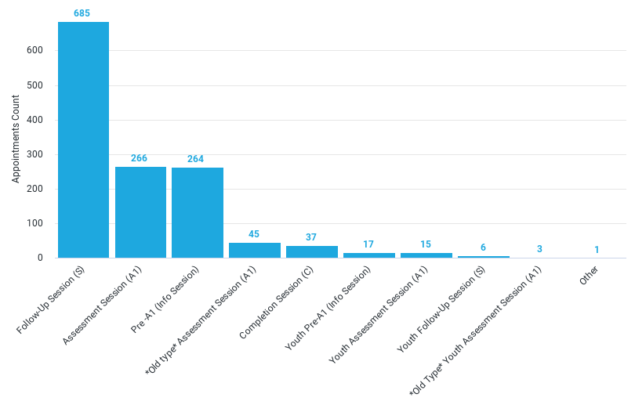

CMHA Housing
MOSS HOUSE

CMHA of Northern BC continues to operate a subsidized housing program for individuals with severe and persistent mental illness. Moss House is a 5-bedroom home that is occupied by 5 men throughout the year. It is a residential setting for those individuals to live in a safe neighborhood and have great interactions with neighbors. Also, having a family like environment has provided opportunities for social and group interactions. Our two cats Sasha and Charlie continued to thrive in this home.
We have had a stable year with the same residents and have seen great success with 2 residents finding employment in the community. We also made excellent strides at bringing needed repairs to the house with improved safety features for the entrance – and repairing some issues with flooring and equipment. We were able to bring in BC Housing Assessment who have provided us with much needed assessment of replacement time lines for all the features of Moss House from furnace replacement to roof replacement etc. In this way the Board of Directors can now ensure adequate funds are set aside each year conduct timely replacements and repairs.

Connections Wellness Centre
Funded by CFIF and Sales
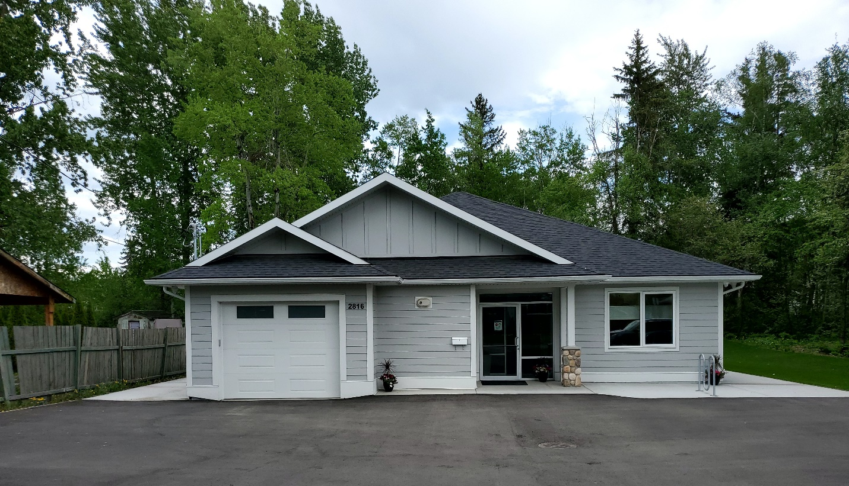
Over the past year there have been many positive changes at the Connections. In June of 2021 we were able to move into the new facility, we didn’t have an occupancy permit, which meant we could not open up to the public. During this time, we set a plan for what the new Clubhouse programming would look like and how to incorporate the Recovery College format into the programming. We furnished and prepared the Clubhouse for opening. We received the occupancy permit in December of 2021. As well we have a dedicated Clubhouse Coordinator position occupied by Cheryl Young. We are very appreciative of Northern Health allowing their .6 vocational position to be allocated to the Wellness Centre combined with .4 funding from our previous full time reception position which was no longer required due to changes in office hours.
In September of 2021, we contracted the carpentry class from CNC to build us a shed for the back yard at the Clubhouse.
In October of 2021, Lafarge, Prince George, paved the parking lot at Connections Clubhouse.
We were awarded a startup grant from the United Way of BC, to start up a Men’s Shed in Prince George In September of 2021. In October 2021, we started planning to develop the Men’s Shed for Prince George. We sent 2 CMHA representatives to Squamish to attend the BC Men’s Shed conference. We gained a wealth of knowledge on Men’s Sheds and the offer of support to assist us in starting a Men’s Shed in Prince George, from the Vanderhoof’s Men’s Shed members. Once back from the conference, we held information session and invited the public to attend. We had a total of 35 men attend during the 3 sessions we held. In January 2022, leadership team for the PG Men’s Shed was selected. CMHA applied for grants from the Community Foundation and the United Way of BC on behalf of the Men’s Shed. Both applications were successful and the Men’s Shed was awarded $7,000 from the Community Foundation and 10,000 from the United Way of BC. At the end of March 2022, the Men’s Shed had 7 men on the leadership team and 13 paid members.
From January – April 2022, Connections facilitated practicum placements for two UNBC Social Work students. We had the students research Recovery College, as well as plan and facilitate information sessions for seniors and teens. The purpose of these session was to introduce these groups to Connections and to find out what their interests were and what we could provide in the way of activities or programming, which would keep them coming back. The students facilitated 3 sessions with a total of 35 seniors attending. The students were held 1 session for teens with 8 teens attending.
The Students also developed a manual of how to develop Recovery College workshop.
We opened Connections Clubhouse the week of March 21, 2022. We offered a sewing group, drop in, guest lunches, Art Heals group and we opened the store, Little of This N Little of That, during drop in hours. The sewing group is facilitated by a peer mentor and a community volunteer. Attendance for the 2 sessions in March was 6 people. The Art Heals program is provided in partnership with CMHA and the ACT Team and is facilitated by Anna Maria from Two Rivers Art Gallery. For the Art Heals group, 7 people attended in March. Drop in had 5 people attend in March.
At Connections, we provided 5 Vocational placements in March 2022 and hope to see many more as Covid restrictions lift.

Employment Supports, Mosaic Employment Services and Outreach
Funded by CLBC

This program – funded by CLBC – went through significant changes, as the contract expanded to include outreach services. We continued to receive referrals for employment but as there was less and less demand then the outreach portion of the work expanded significantly. Our goal remains to assist clients with neurological, developmental and/or physical disabilities who are also impacted by mental illness/addictions, to live and work successfully in the community by determining appropriate care and interventions to meet individual needs and situational requirements. This mixed year of covid restriction and lifting of restrictions allowed for us to present Living Life to the Full which is a licensed program of CMHA. Our staff did a wonderful job of adapting the learning to individuals with neurological and learning challenges and the training was well received and attend by 8 people. It was also wonderful to be able to present this group in our new Wellness Centre which is a wonderful environment to learn within.
Employment & Outreach Support Appointments
~April 2021 – March 2022~

Total Appointments: 1,232

Employment & Outreach Support Client Age & Gender
~April 2021 – March 2022~

The average age is 31 years old

Forensics Life Skill Program
Funded by Forensic Services

The Forensics Life Skills Program works with individuals referred by Forensic Psychiatric Services Commission (FPSC). This full-time position is giving individuals living with mental illness and/or addictions who have been in conflict with the law more support in maintaining stability and moving towards independent living. The Forensics Life Skills program provided support to 6 clients. As with all our programming, the forensic life skills client is also working towards the long-term goal of reintegration into community with zero recidivism. Within that large goal are many smaller objectives that are celebrated upon achievement with the setting of new objectives once previous ones are successful.

Covid also hit this program hard so the focus became keeping people stable and as healthy as possible with either in person or virtual connections. The prison and court systems were heavily impacted by Covid and many people who would have been incarcerated were actually left in community because the prisons were not accepting any new residents during the heavy Covid periods. Consequently, court was also delayed—for some, court sentencing was delayed close to a year.

Forensic LifeSkills Appointments
~April 2021 – March 2022~

Forensic Lifeskills Client Gender & Age
~April 2021 – March 2022~

Average age: 43 years old.
Forensic Peer Support
Funded by Civil Forfeitures of BC

Unfortunately, we were unable to find funding to continue this vital program so have had to shut down the program as of May of 2021. The success of this program is specifically highlighted in the example of one participant who we continue to support under the auspices of life skills. This individual was released on the courthouse steps with no housing, no medication and no support beyond what was arranged with CMHA. We have helped her to navigate to permanent housing, support with her children, gaining appropriate medication and health care provision. The stresses we have supported her through could easily have invited her into relapse positions and re-entry to jail but instead she is on her way to a family treatment program with her children and a sense of hope for her life.
We believe this level of support is essential for all those individuals leaving the prison setting and unfortunately this level of support is rarely available. We hope to find funding or even a research project that could allow us to reactivate this program and find a way to make it a permanent resource in Prince George.

Housing Outreach
Funded by City of Prince George and the United Way

Resource Housing Outreach is a 16 hours per week part time position assisting people who are experiencing mental health concerns access affordable and safe housing in the community. In 2021/22 fiscal year, an average of 5 people per week had appointments for information on services and/or assistance per month which is a significant drop from our pre-Covid numbers of 30 per week. As our main office remained closed to walk ins during Covid, people had to make appointments which certainly added a barrier for those who wanted to walk in. Ability to house people was virtually impossible due to low rental availability and the fact that one bedrooms or studio apartments were now well out of reach of the $375 a month housing allowance for those living in financial poverty.

The HIP committee continued to meet but really struggled with purpose and engagement. At the end of the 2021/22 fiscal year we said goodbye to HIP and hello to HIP as it's own non-profit society and a similar direction. It is hoped this committee will still remain core to the management of homeless needs in Prince George.

Due to Covid, no Ready to Rent (Rent Smart) courses were able to occur, and we look forward to the day that this course can recommence providing the following:

- Tenant and Landlord rights and responsibilities; living effectively with others, communication skills, budgeting and planning for stability, maintenances dos and don'ts, crisis management, safety and pests.

Appointments
~April 2021 – March 2022~

Total Appointments: 262
____________________________________________________________________________________
Housing Outreach Patient Age & Gender
~April 2021 – March 2022~ average age 41

Life Skills Outreach
Funded by Northern Health

The Life Skills Program continues to play a vital role for CMHA of Northern BC and the people we serve. Life Skills provides one-on-one support to individuals with mental health/addiction concerns to achieve independent living within community. Our Life Skills team is comprised of 4 full time staff providing services to individuals who are referred by Northern Health staff, family doctors or other agencies and supported self-referrals.
We deliver services seven days a week - 365 days a year and in 2020/21 we served 62 unique individuals with different goals and objectives designed to help them achieve stable mental health. This is a 26% increase over the 2020/21 fiscal year. The types of services provided can be budgeting, self-care, home maintenance, hygiene, communication skills, physical health improvements, increasing social supports etc. We work in partnership with any other support people involved in the individual's life. We work on assisting people to uncover underlying issues contributing to the presenting problems such as social anxiety, generalized anxiety, depression etc. Participation in case conferences with the individuals we work with is an important element of the overall case planning that takes place.
We continued to provide funded frozen meals to clients struggling to leave their home for groceries and assisted with other issues that were occurring due to anxiety increases from Covid. Our goal work changed for many clients as we focused on assisting them with maintaining their mental health under the isolation that was now a reality in their lives.

Life Skills Appointments
~April 2021 – March 2022~

Life Skills Clients Gender & Age
~April 2021 – March 2022~

Average age: 49 years old.

Little of This N’ Little of That
‘Little of This N’ Little of That’ was a low-cost canteen-style store operating out of Connections Clubhouse from 9am -1pm Monday to Friday. This store provided affordable, individually packaged, single served goods for people who live on a fixed budget and can’t always afford to buy groceries in bulk. Groceries were purchased in bulk then divided and individually packaged. The store served as a training site in the Vocational Program for individuals living with mental health and addiction issues where they could volunteer and develop new job skills. This store is now working on reopening in the new Connections Wellness Centre and will be greatly appreciated by all once it is able to be operational again.

NEW DIRECTIONS HOUSING
Funded by BC Housing and Residents

CMHA of Northern BC operates 19 BC Housing subsidized housing units for persons with severe and persistent mental illness. Subsidized units are located throughout Prince George in various apartment buildings which provides individuals with safe and affordable housing. Staff provides 5 hours a week in support to this program.

The New Directions role is to:
- Intake for applicants and find housing to meet client’s needs.
- Develop and maintain connections with landlords and tenants.
- Resolve housing issues such as repair and maintenance concerns to landlords.
- Submit all yearly evaluations/rental increases to BC Housing.

We had three individuals leave our subsidized programming either because they now qualified for SAFER or also a very unfortunate death. We are still in discussion with BC Housing to ensure safety of this housing as the 30+ year contracts begin to come to an end.

New Directions Appointments
~April 2021 – March 2022~

New Directions Client Age & Gender
~April 2021 – March 2022~ average age 48

Peer Support
Funded by Northern Health

Peer Support is a well-researched model of service delivery where a peer with lived experience of the mental illness/addictions and recovery process provides mentorship and support to another individual faced with a similar path of recovery. The Peer Support Program (.6FTE) provides a variety of activities to help mental health consumers, both in office and outreach in the community. Covid changed the picture for us significantly and the bulk of our peer support work has been channeled to those impacted by the opioid crisis and the homeless population outside our front doors. Overall the program has served 46 individuals with a wide variety of needs. The concerns of those who are unhoused continues to be a polarizing issue in our community and we continue to provide support to those individuals who are often targeted for significant harassment and discrimination. All of our peer support workers have received their certification with Peer Support Canada.
Peer Support Outreach - is a specialized program that provides peer support for those individuals who have been released from the psychiatric ward directly to a shelter or to the streets. This program has been funded by the City of Prince George and by a Covid grant managed by the United Way. Those individuals released in such a manner are sent out with appointments and zero support resulting in dropped prescriptions and lack of follow through. Our programming has greatly assisted in the stability of those often called by derogatory names like "frequent flyers. We have served 12 such individuals in the 2021/22 fiscal year. Peer Support with this population also tends to mean a significant amount of hunting people out on the street as they often have no phones and no ability to leave messages.
The Positively Peer Program and One on One Program provide support and community resources to patients on the psychiatric unit at the hospital. It has been awesome to see that the psychiatric ward is opening up again and we began
Keeping in Touch program (KIT) provides phone support for individuals who have left an institutional setting and can benefit from a supportive weekly phone call to help with transition. This program was maintained through Covid and served on average 5-8 people a week with Devin Sluchinski providing the supports.
Peers Prospective Newsletter. Thanks to Devin Sluchinski who has commenced the republishing of this newsletter in our 2021/22 fiscal period.

Peer Support Appointments
~April 2021 – March 2022~

Peer Support Client Age & Gender
~April 2021 – March 2022~

Average age: 45 Years old.

Peer Support Northern BC
Funded by CMHA BC Division and Northern Initiative Development

With some funds from BC Division, we were able to support the development of peer support programs in Houston, Smithers, Atlin, Haida Gwaii and Burns Lake. Those communities are all working hard to have their peer support workers accredited with Peer Support Canada. As this is one time only funding we are hoping they will have the ability to seek further funding to continue the valuable work they are doing in their communities. This program is being supported and supervised by Stephanie Aaslie Clinical Coordinator.

Our partnership with OSI - Can continues to grow under the leadership of Ron Blinn. Ron has been able to set up Frist Responder support groups in Houston, Fraser Lake, Topley, Granisle, Vanderhoof, Southside Burns Lake, Telkwa, Ft St James, Smithers, Prince George. He is now dealing with urgent requests for programs in Terrace, Kitimat, Prince Rupert, Valemount, Mackenzie, Quesnel, Williams Lake, 100 Mile House and Cache Creek.

The demand is huge and the need is growing as more and more impacts of PSD etc are being felt with our first responders particularly with the significant cuts to ambulance etc.

Public Education
Funded by Sales and Gaming Funds

Our Public Education program took a large hit through the past fiscal year with significant reduction in workshops presented and many last-minute cancellations as we navigated the ongoing changes in health orders. It was also a year of technology as we learned how to navigate the world of virtual training—the etiquette rules, the breakout rooms, and the ongoing cry of "you are on mute". Nonetheless, we did some valuable work and trained new staff in presentation skills, and we anticipate that once Covid retreats, the demand for this program will skyrocket and we feel prepared to meet that challenge.

Quesnel - Clinical Program
Funded by the Red Cross

The Quesnel office has been consistently busy this year. We have continued to see individuals in person, over the phone and virtually. We were able to facilitate a Mental Health First Aid that was sponsored by the Rotary Club of Quesnel where 10 people received their MHFA certificate. Through community networking a one-hour course on resiliency for AXIS was also facilitated and nine people attended.
We continue to participate in committees to network and strengthen/develop community partnerships. One of these partnerships was having a social work practicum student join our office to complete their third-year practicum. We also have worked with a group of community partners to bring a Situation Table to our community and continue to support our local Community Action Team
Our goal for this year is to continue to meet people where they are at in a non-judgmentally and with empathy. We know and as our statistics and feedback from community resources, partners and community members demonstrate that this office needs to stay open so securing funding to ensure this happens is another main focus of ours for the upcoming year.

Quesnel Total appointments
~April 2021 – March 2022~

Total: 488 appointments
Goals & Objectives completed: 255

Quesnel Client Age & Gender
~April 2021 – March 2022~

48 female clients & 27 male clients
Average Age: 43 Years old

Mental Health Conditions

_______________________________________________________________________________________________________

This chart shows us that PTSD, Anxiety, and Situational Crisis are the 3 leading mental health conditions that our clients in Quesnel are dealing with.
_______________________________________________________________________________________________________

Quesnel - Food Coordination Program
Funded by Private Donor

Food Recovery has continued to be an essential need in Quesnel through the 2021/22 year and we have had significant support from the community. In particular the West Lake Mills have contributed large sums of money to maintain the good food box program which works in partnership with Long Table Grocery to ensure that those in need can receive food specific to their dietary needs. In keeping with our philosophy this is not a program that requires people to demonstrate "need" so there is no need to show rent and utility receipts etc.
We continue to work on building partnerships in the community but it has been a bit of a struggle primarily due to Covid exhaustion and a sense of community isolation and struggle. Quesnel continue to be impacted by a great deal of trauma and as a result there has been a move towards taking "sides" and struggling to understand the views of each side. Those impacted by financial poverty have grown in numbers and the shame and judgement unfortunately has also grown.
A significant positive accomplishment has been the acceptance into a three year grant project with the Vancouver Foundation and we are hopeful that this will ensure the stability moving forward that is needed. Huge thanks to Kirsten Balaski for her successful submission.

_______________________________________________________________________________________________________

Second Chance Thrift Store
Funded by Sales and by Gaming for Skills Development

Second Chance is a social enterprise thrift store which was typically open Monday- Friday 10:00 am – 4:00 pm. It provided good quality, clean items and clothes to the community at a low cost. The store relied on donations from our community to keep it stocked. Store purpose was to provide vocational training sites for individuals recovering from mental illness and/or addictions.
Due to Covid, the store has remained closed.

_______________________________________________________________________________________________________

Two Rivers Catering
Funded by:
Sales from Catering
With Gaming Support for Skills Development

Two Rivers Catering has continued to expand despite and likely because of Covid. A significant amount of work is now focused on providing healthy meals to those living within shelter context through ASAP, Pounds and AWAC. Covid has significantly reduced community activities and catering and this shelter work has been highly stabilizing as we look forward to the increases coming with breakfast and lunch meals served at 1st Avenue and at the Aboriginal Housing Seniors facility due to open in November 2022.
The 2021/22 fiscal year saw Two Rivers being able to return home to Connections Wellness Centre and a lovely new kitchen! This represents a full circle return plus the ability to have a full non-industrial kitchen with excellent tools allowing for even better product output and an excellent working space for those individuals recovering from mental illness and working on vocational goals. We have had some significant individual successes and are celebrating one individual s ability to now live fully independently and another person who is getting their driver's license with all the independence that will provide! Probably the largest indicator of success is that only one individual was hospitalized during this time period and although work is not the only contributor to this success we do know that the stability of a work environment and the concept of being able to come regularly to a place where you know you belong is a huge contributor to mental health and wellness.

- $170,750 from Active Support Against Poverty meal program
- 18,195 from Pounds meal program
- 1,800 from Holidays of Hope turkey dinners (funded by donations)
- 900 from Alliance BC
- 525 from BC Housing
- 633 from Walking in Wellness Group

This represented total sales of $192,803 and a 28.7% sales to cost ratio which is well above the 35% standard that is aimed for.

$40,000 from Gaming continued to provide the essential funding to support the clients who work at Two Rivers Catering to ensure they have the support and guidance they need to do a great job. We are proud to have another injury free year and a core group of 6 individuals learning the catering business and 4 new individuals brought on.

Vocational Support
Funded by Northern Health

The Vocational Support Program has previously worked in collaboration with Rehab Services of Mental Health and Addictions, Northern Health. However, Covid resulted in a complete shut down of the rehab programming and CMHA was the only part of that program that continued. We hope to see this come back as covid restrictions lift. The Vocational Support Programs goal is to assist clients that live with mental illness and / or addiction issues in developing vocational skills. By developing employment readiness skills individuals can improve their chances of success as they work toward finding paid employment, volunteer positions or educational opportunities in their area of interest. CMHA has 2 FTE vocational staff and .6 Wellness Centre Coordinator.

Vocational Support Appointments
~April 2021 – March 2022~

Vocational Support Client Gender & Age
~April 2021 – March 2022~average age 51

EVENTS & PROJECTS

Mental Health Week
May 3-9, 2021

Covid invited us into a new process of virtual work during this week.
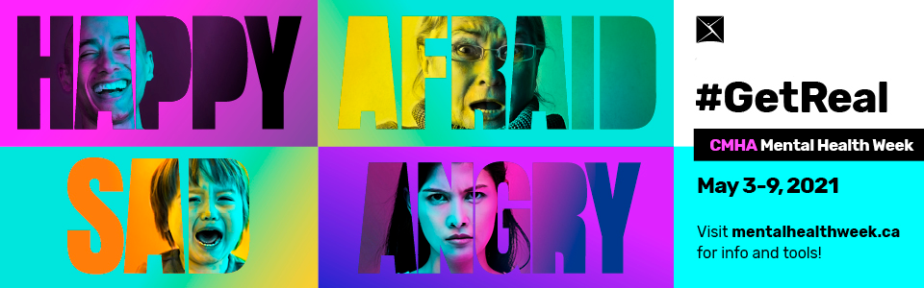
We relied heavily on the media toolkit provided by CMHA National and did several media interviews as well as broadly promoting social media to inform about the self-care needed during the pandemic.

This campaign was all about naming our feelings and being open about sharing them as a way to ensure we maintain our mental health during these tough times as Covid extended into year 3.

Depression Screening/ Beyond the Blues

Although planning for Beyond the Blues took place during the fiscal year of 2021/22 we did not hold an actual event during this fiscal year. Covid restrictions and the university time line was not conducive to moving forward with a virtual or in place event.

Ride Don’t Hide
June 2021

This was our return to a ride after cancellation of it due to Covid. This was a virtual event covering the entire month of June and opened up the event to people choosing their health activity and tracking how many minutes, hours, km or breaths they took. This meant people could now track dancing, yoga, bike riding, horseback riding, meditating etc - whatever they do that assists their mental wellness. This had many positive outcomes and options for people while others very much missed the face to face interaction of a one day event. Moving forward we intend to look carefully at the financial and personnel base costs compared to the benefits (many of which are hard to measure!)
_____________________________________________________________________________________

Holidays of Hope - December 2021
Funded by Donations

Due to Covid we continued with our process from 2020 and focused solely on CMHA clients and their children. We provided gift cards and frozen turkey dinner to all our clients as well as gift bags for children they applied for.

We raised $9,225 in donations and spend $9,500 in gift cards and frozen meals. Our clients expressed gratitude for what was provided to them and fully understood the inability to get together due to Covid.

_____________________________________________________________________________________

Walking for Wellness - fall of 2021
Funded by the City of Prince George and registration
This was a 6-week trail walking clinic for women designed to enhance mental and physical health. Group members safely explored trails in Prince George, BC while connecting with fellow community members and improving their mental wellness. This clinic was led by a registered clinical counselor and physical education professional Sue MacDonald (On the Ground Consulting and Counselling) with a group of experienced trail walkers.
There was a split offered this year as several women wanted to return again but it was deemed more appropriate for them to attend an advanced group which was called the Walking Warriors. 20 women attended the basic Walking for Wellness and 15 completed the Warriors group. All completed their event with rave reviews. This program was funded by a generous grant from the City of Prince George combined with sales from participants able to afford the registration. Two women were subsidized to attend this program and one of our Life Skills workers Cheryl Young provided much needed support to one of those women.
_______________________________________________________________________
HML Counselling – April 1, 2021 to March 31, 2022
Funded by Community Action Initiative

Community Action Initiative Funding continued to support this initiative which was begun due to Covid - We are hopeful that the Provincial Government will see fit to make this program a permanent feature for us. This initiative is designed to provide therapeutic services to individuals receiving CMHA services through one of our many programs who are stalled in their progress due to mental health issues and a lack of counselling support or access to counselling techniques. Unfortunately many of our clients have been unable to access services that might assist them with the management of anxiety or depression or schizophrenia etc.

The Masters level therapists and 2 students working on their Masters in Counselling provided 58 clients with over 2,500 therapeutic sessions between April 1, 2021 and March 31, 2022. As well 13 group sessions were provided delivering a group called Buried in Treasures which focuses on assisting those impacted by hoarding.

This program goes a very long way to assisting our staff in moving forward on the goals the individual has noted they wish to work on. So many times it is our inability to work with our emotions or to have tools to manage the impact of our emotions that can have us fall back into mental illness or stall in our progress. This counselling has made a huge difference for our work and our clients success and we are now noting that Northern Health is requesting ways that they can get clients into our counselling who do not require life skills or vocational. It is an unfortunate sign of our times that more and more individuals and families are needing clinical therapeutic supports with dwindling therapeutic resources.
_____________________________________________________________________________________

UNBC Student Wellness

CMHA of Northern BC has been asked to sit on the UNBC Student Wellness Committee which is a wonderful project occurring throughout the Canadian university system to ensure that all student programming meets a minimum of mental health standards. What has stood out in this work are some of the barriers as well as the fact that faculty mental health is also critical for a healthy university campus.

_____________________________________________________________________________________

PEOPLE OF CMHA
CMHA Board of Directors 2021-2022
The Board of Directors has moved into a virtual and in person process for a few months in 2021/22 fiscal period. The lack of face to face interaction has definitely made it more difficult for the board to do its work and we relied more on email motions. It is hoped that the return to face to face meetings will assist the stability of the board.

Jeffrey Wayow | President
Orestine Ostapiuk | Secretary/Treasurer
Andrew Kurc | Secretary
 | Vice President
Arsham Javaherdashti | Director
Glen Schmidt | Director
Marlo Kawchuk  Nadia Mansour  Khushi Brahmbhatt  Joseph Lang  Nadira Begum | Director  Director  Director  Director  Director

_______________________________________________________________________________________________________

Volunteers

Due to Covid 19 and the agency shutting its doors to walk-ins, the volunteer program took a sharp dive. Volunteers remained active on the Board of Directors but the activities related to info fairs and booths were in sharp decline as well as the activities within the thrift store and other services as completed by volunteers. We miss you!!!

_______________________________________________________________________________________________________

Staff 2021/22

Adebimp Abioe  Allen Zgaga  Amanda Lemky  Anita Antonenko | Casual  Chef Two Rivers Catering  Admin and Volunteer Coordinator  Casual Life Skills
Belinda Davidson  Brent McLachlan  Briana Marshal | Program Manager  Casual  Bounce Back Scheduler
Cassie French  Charmaine Makelke | Life Skills  Casual
Cheryl Young  Christine Mackay | Vocational Support  Peer support and Outreach
Corbin Bright | Food Recovery Coordinator Quesnel
Devin Sluchinski | Peer Support Northern
Ed Lui | Peer Support/ Forensic Peer Support/on leave
Felix Okorafor  Harmanprett Singh | Employment Support Worker/Outreach  Life Skills/Casual
Heidi Wilson | Life Skills/Vocational
Jessica Zaporozan | Life Skills
Jeannine Glowacki | Resource Housing/Life Skills
Jeff Hodson | Life Skills
Jennifer Carter | Admin Assistant/Volunteer coordinator/on leave
Jenny Malyk  Juls Budau  Kaleigh Mesic | Life Skills  Casual/RSW  Casual
Kama Katrinchuk  Katherine Paul  Kim Harrington | Employment Support Worker/Outreach  Executive Assistant/Bounce Back Coach  Food Admin Assistant Quesnel
Kiran Bassi  Kirsten Balaski  Lin Bai | Employment Support Worker/Outreach  Casual assist Quesnel/contract trainer  Accounting Administrator
Lory Moroz  Mae Ward | Bounce Back Coach/contract trainer  Program Manager
Marie Bradley | Vocational Support/Bounce Back Coach
Mary Ellen Johnson | Forensic Life Skills
Mary Lu Spagrud | Manager of Education & Projects
Maureen Davis | Executive Director
Nada Peters | Resource Housing/Peer Support/Program Manager
Nicole Antonenko  Noah Plain  Rebecca Crawford  Shawna Rasmussen  Shauna Russell  Shirley Hogan  Stephanie Aaslie  Tracine Charest  Tyler Leary | Bounce Back Coach/contract trainer  IT  Reception/Housing  Vocational Support  Forensic Peer Support/Executive Assist/RSW  Program Manager/Manager of Education & Projects  Clinical Coordinator Quesnel  Clinical Admin Assistant Quesnel  IT

Thank you

We appreciate all you do for
and with us!

